# **Module 4 Activity 2: Setting up MongoDB in Cloud Environment**

Santrupth Sunkari

Master’s in information technology, Arizona State University

## IFT 544: Middleware Prog & Database Sec (2023 Fall)

Prof. Dinesh Sthapit

October 1, 2023

**Task 1:**

**Data Definition for the JSON data:**

* Id (not required): ObjectId or String
* customerName: String
* phoneNumber: String or Number
* address: String
* loanAmount: Number
* interest: Number
* loanTermYears: Number
* loanType: String
* description: String

Step 1 – Creating by setting up additional environment variables in “config.env”

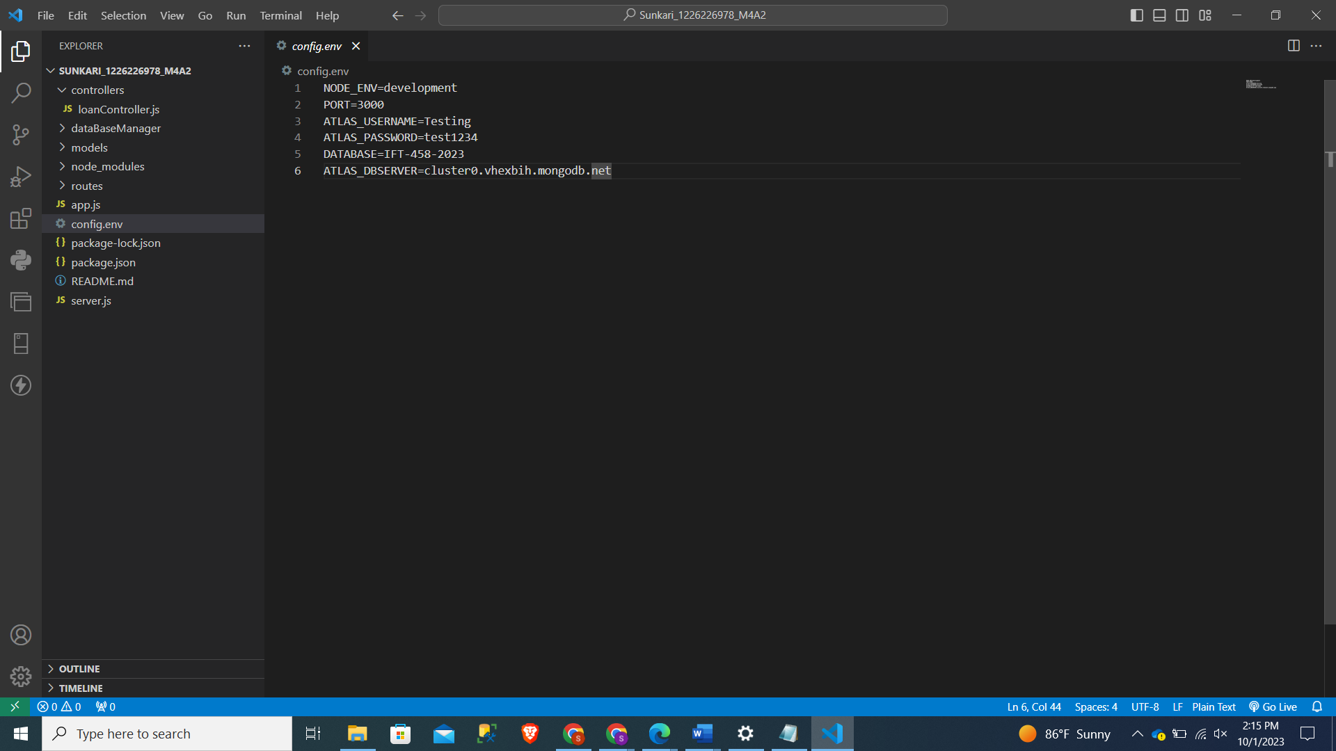

Step 2- Creating Associated files in the respective folders-

loanRoute.js, loanController.js and loanModel.js in the respective folders:

loanRoute.js

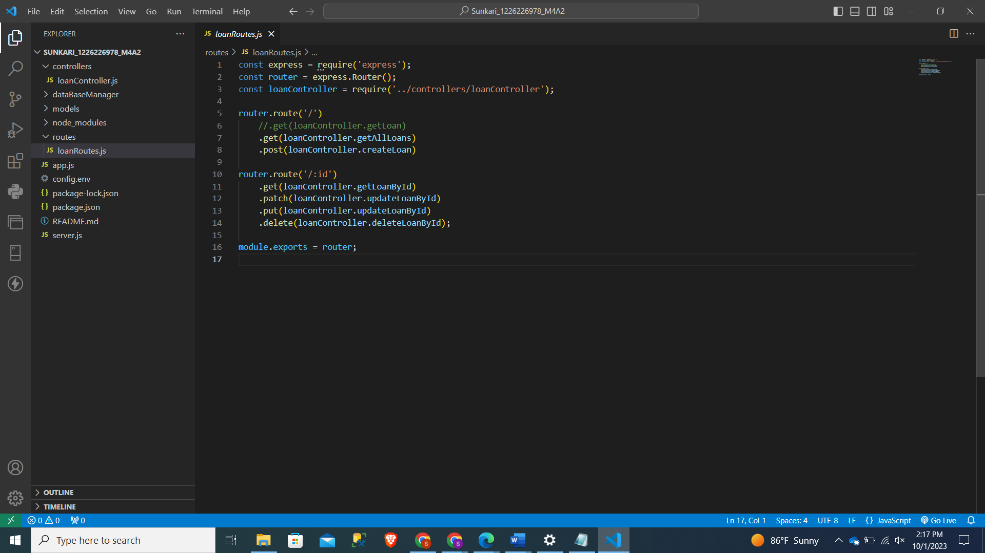

loanController.js

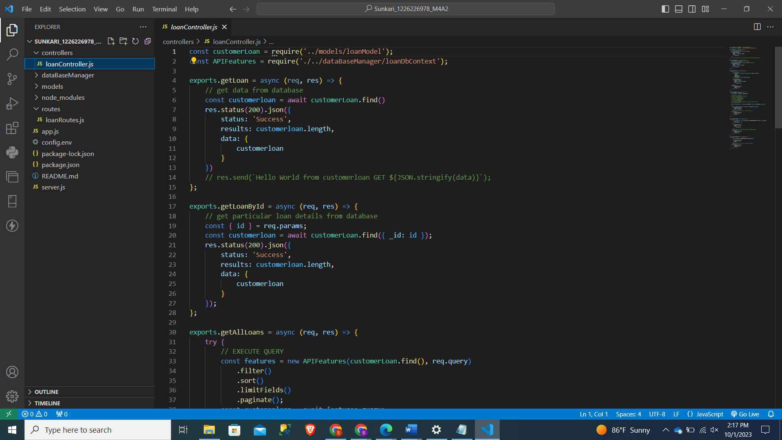

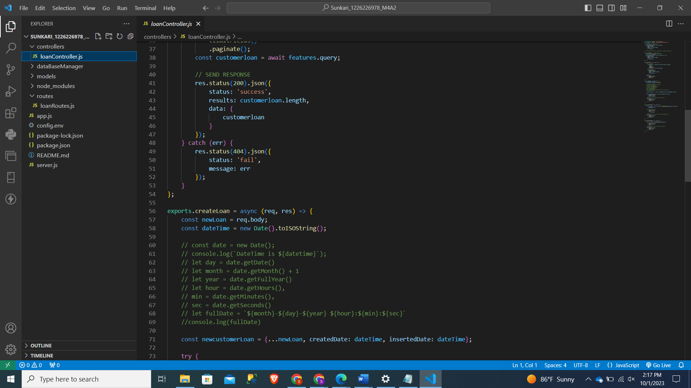

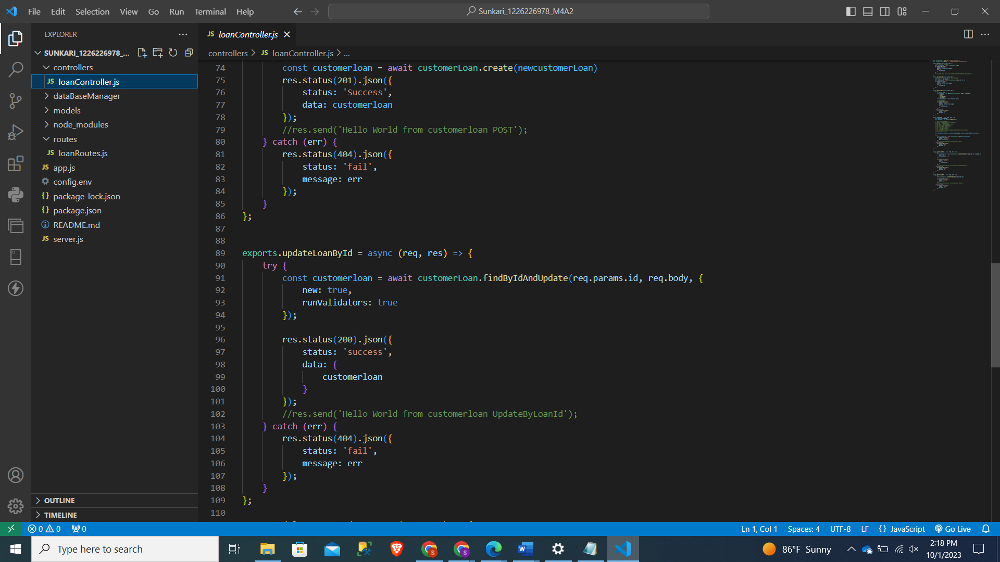

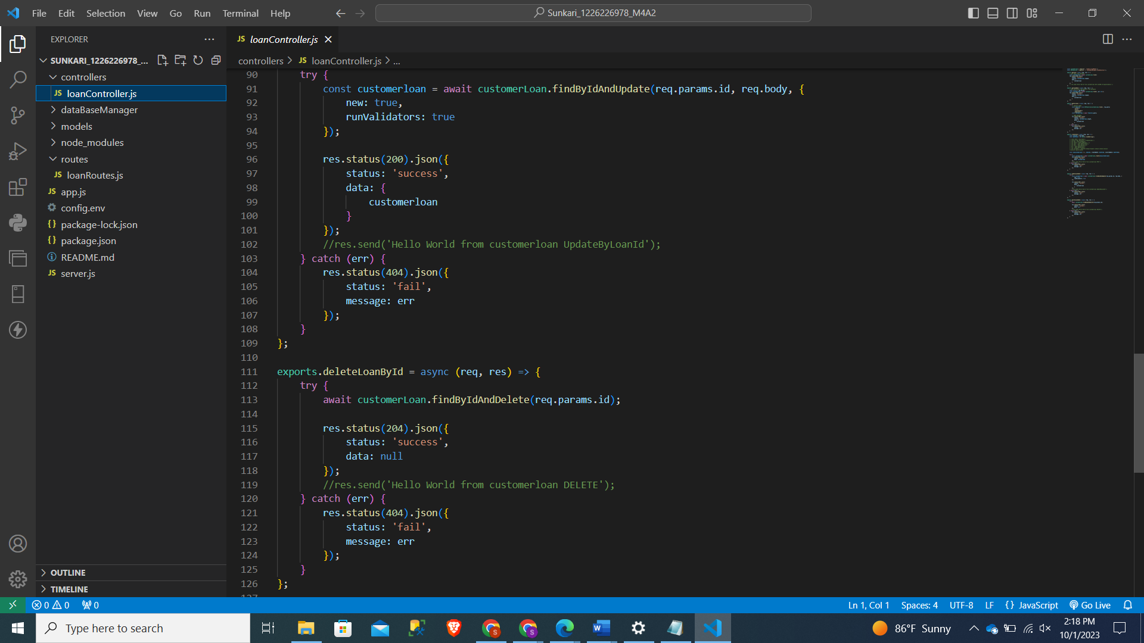

loanModel.js

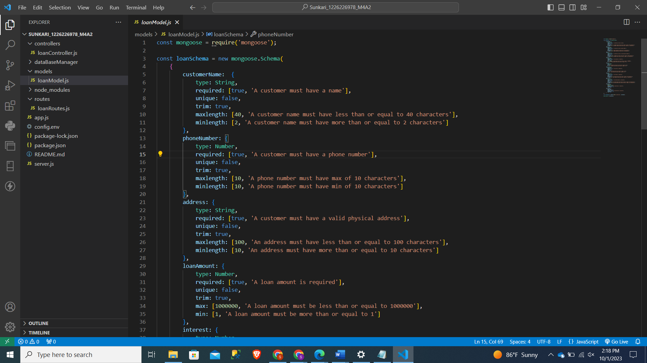

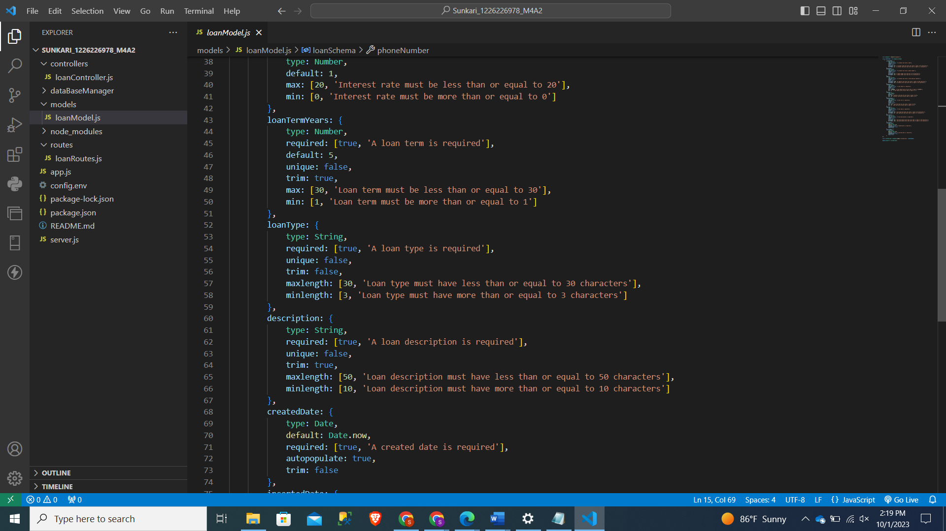

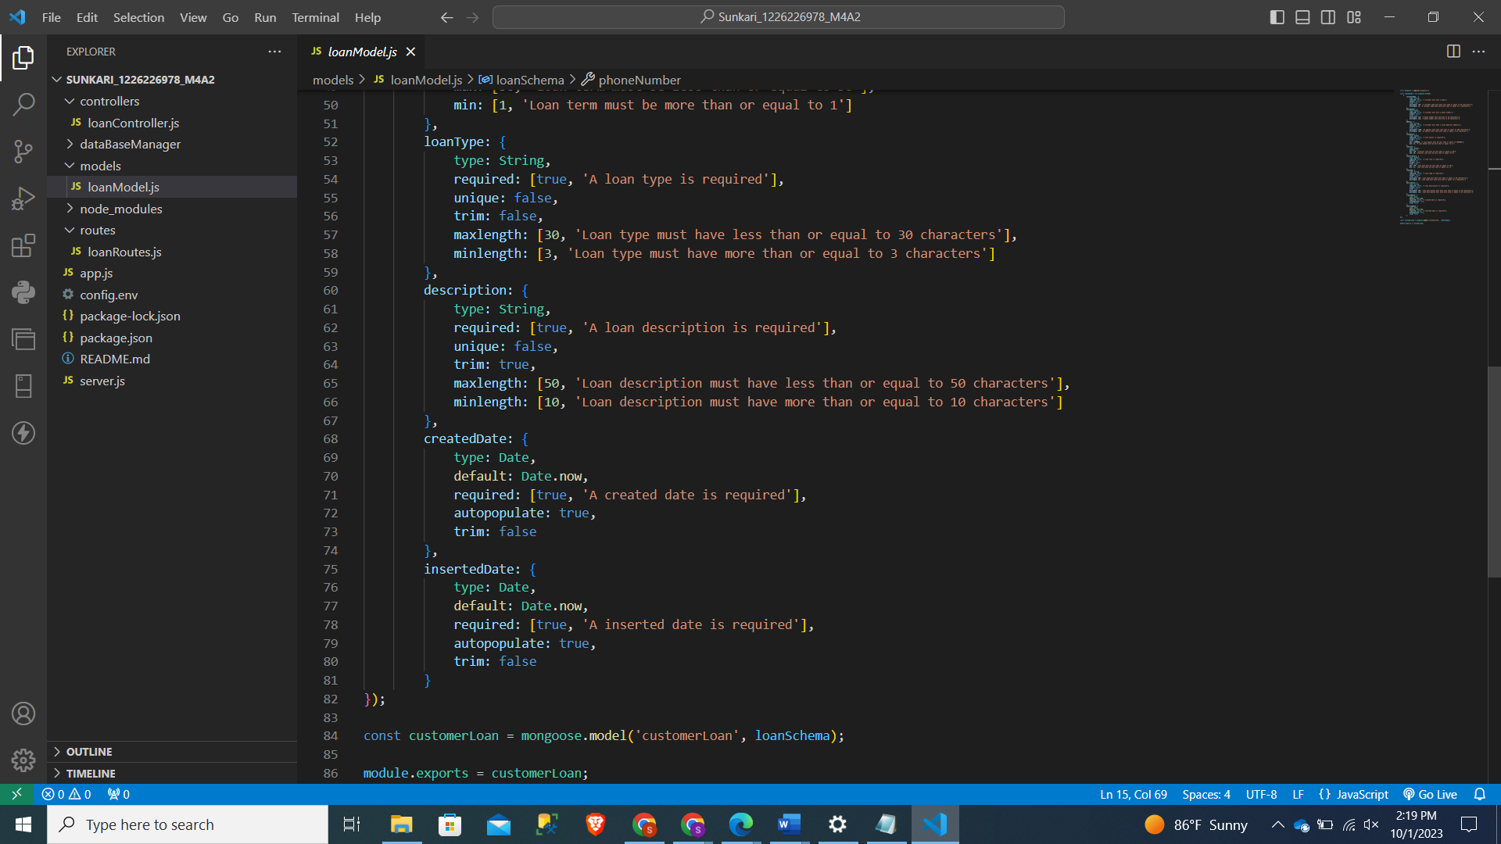

Step 3- Server.js

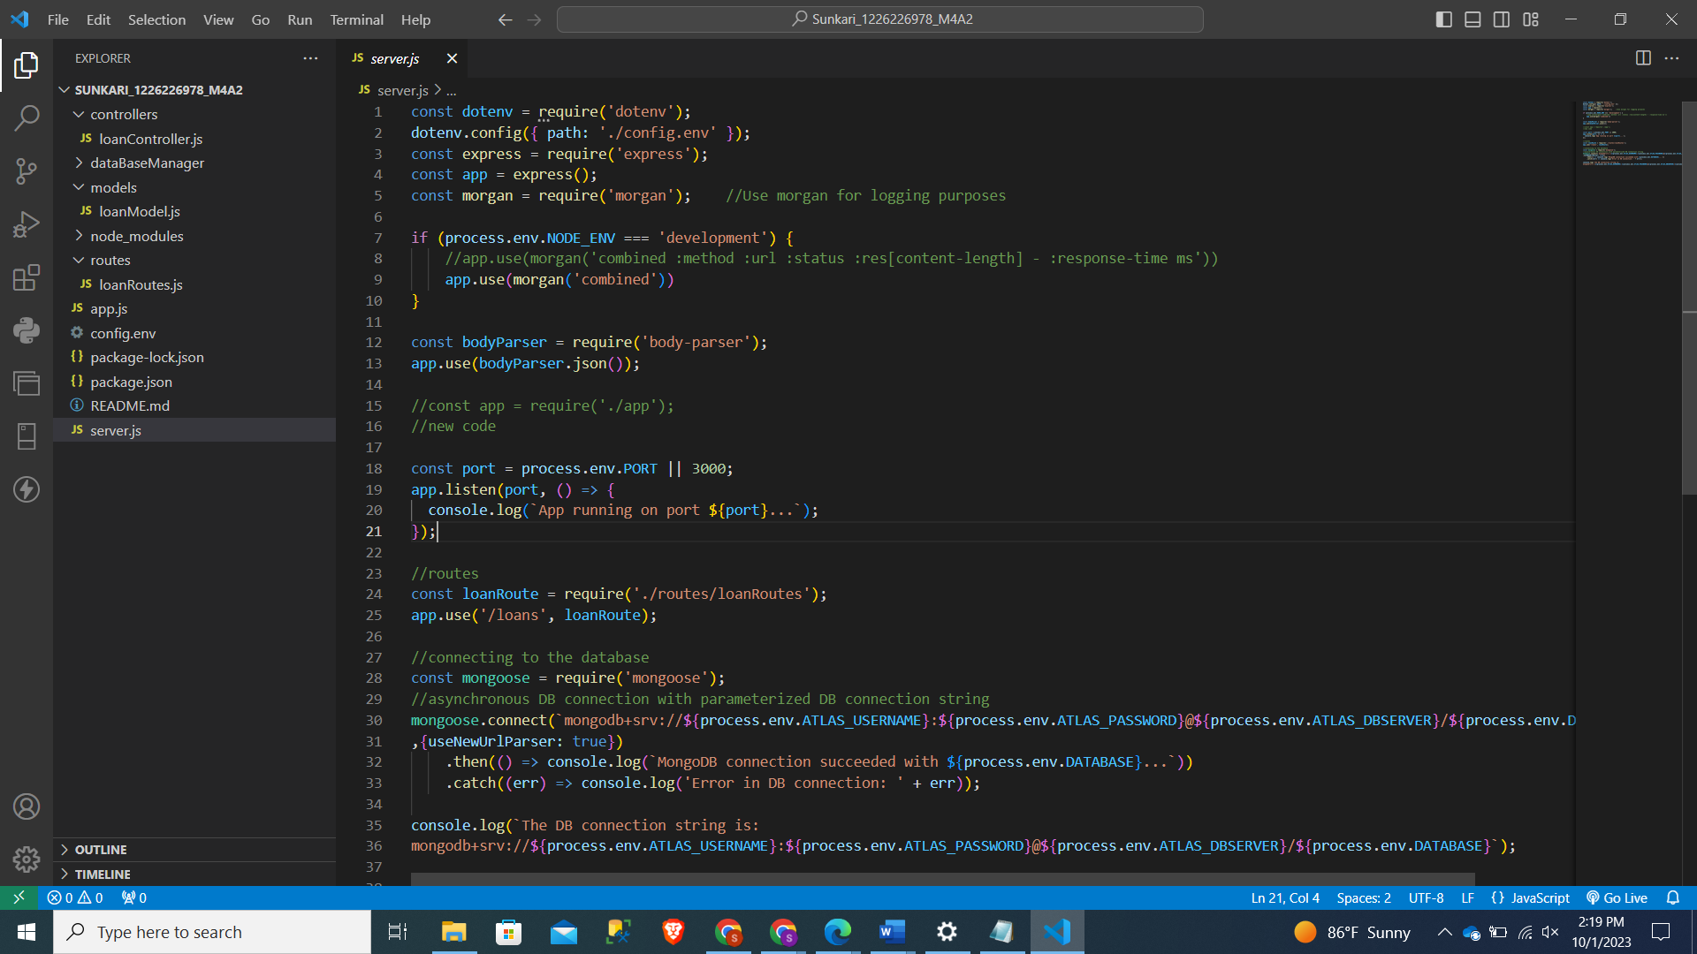

Step 4- Creation of a folder and naming it as database Manager

loanDbContext.js

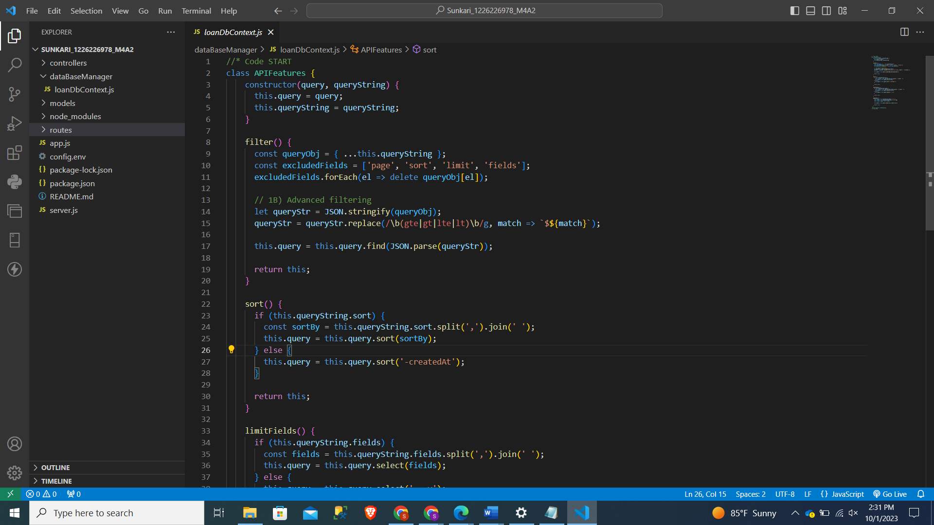

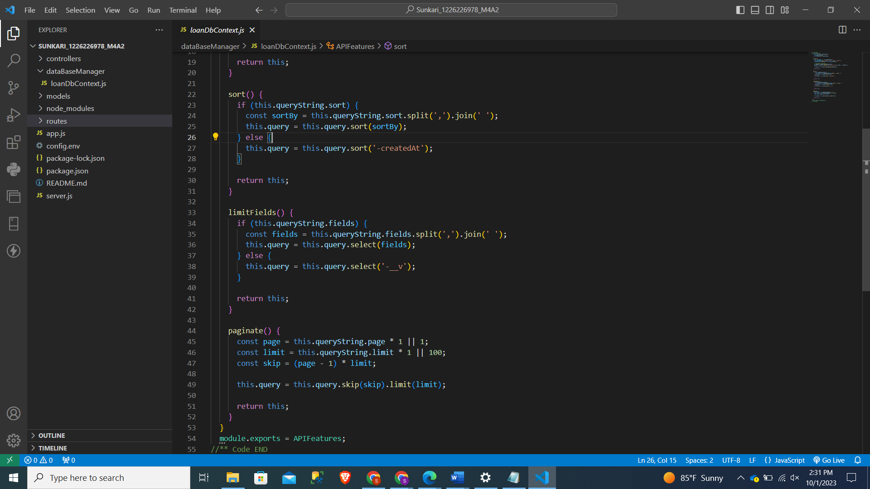

Step 5 – Controller File

loanController.js

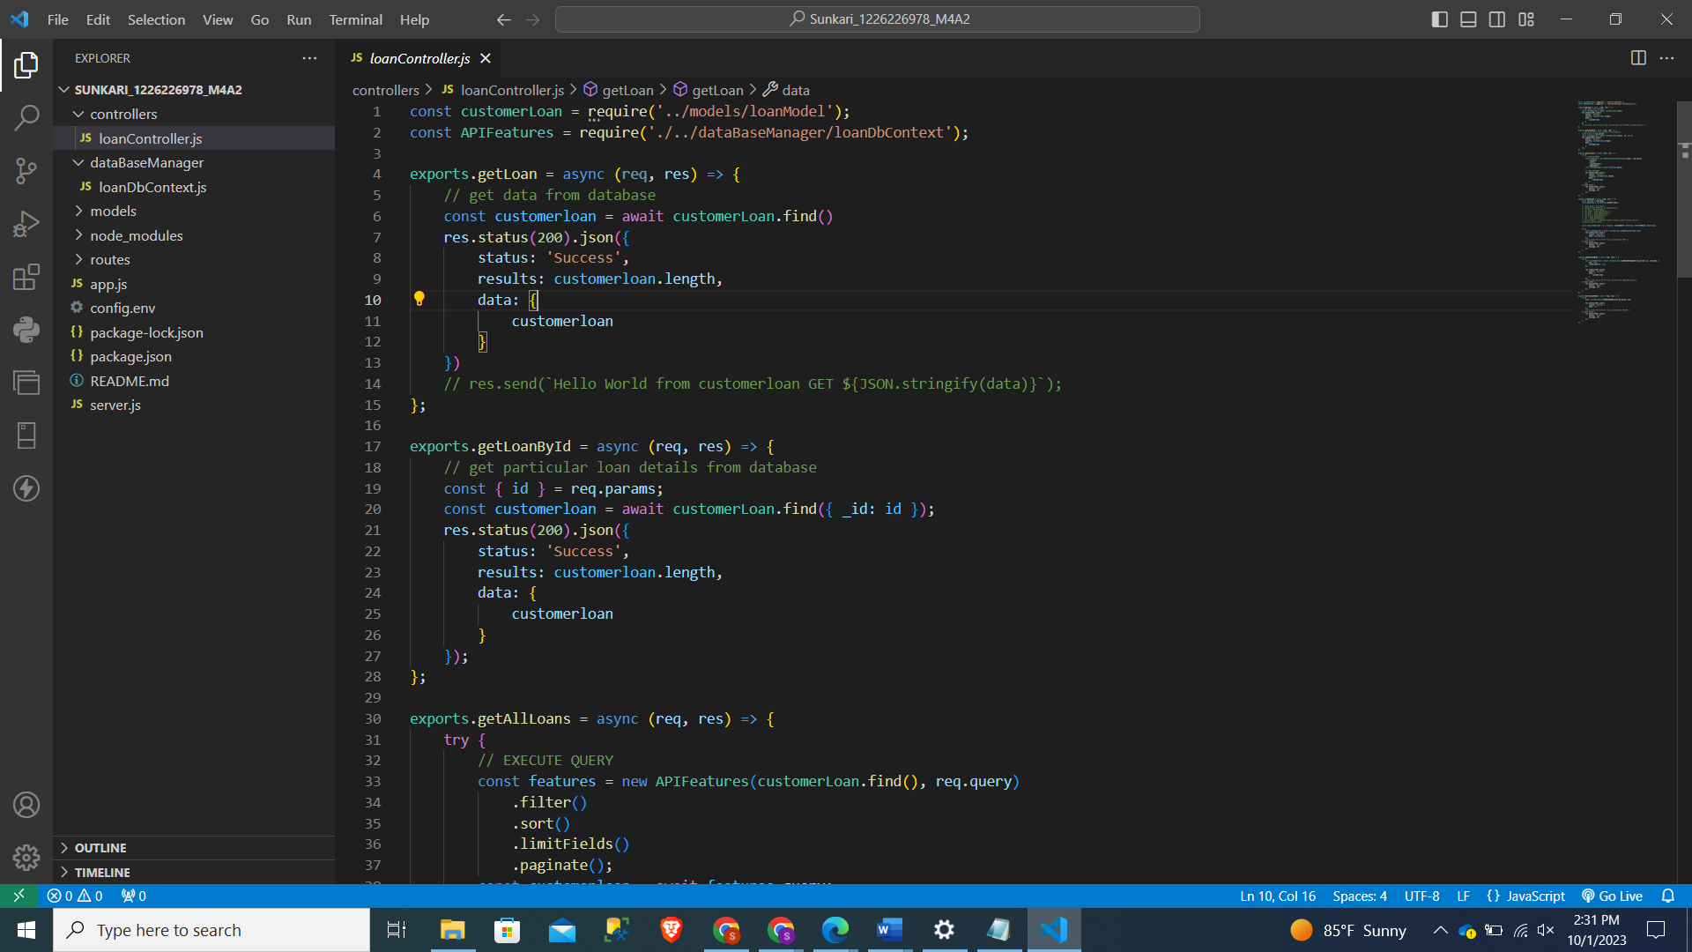

Step 6- App.js

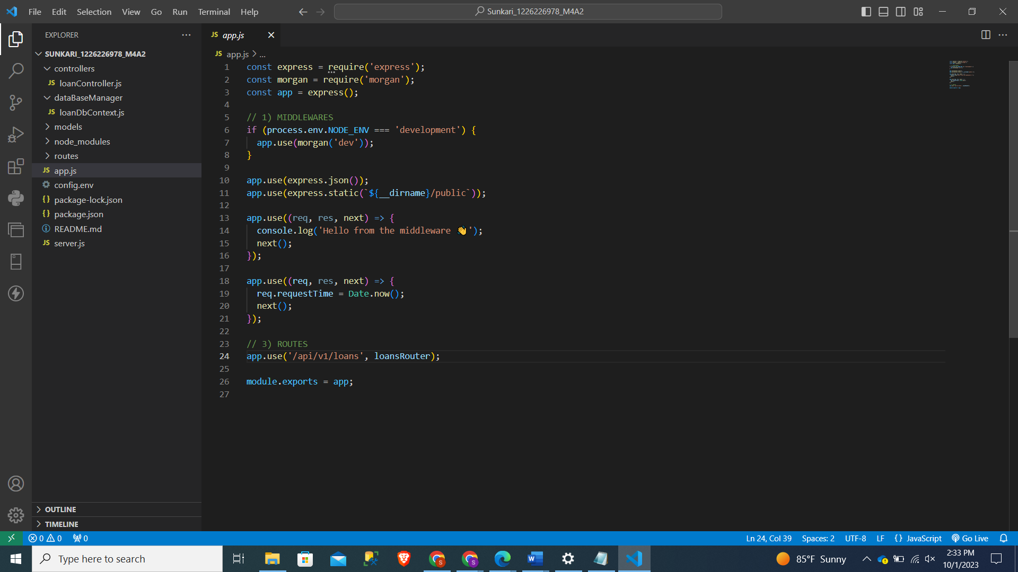

Step 7 – App running with successful displaying the Port number and Listening

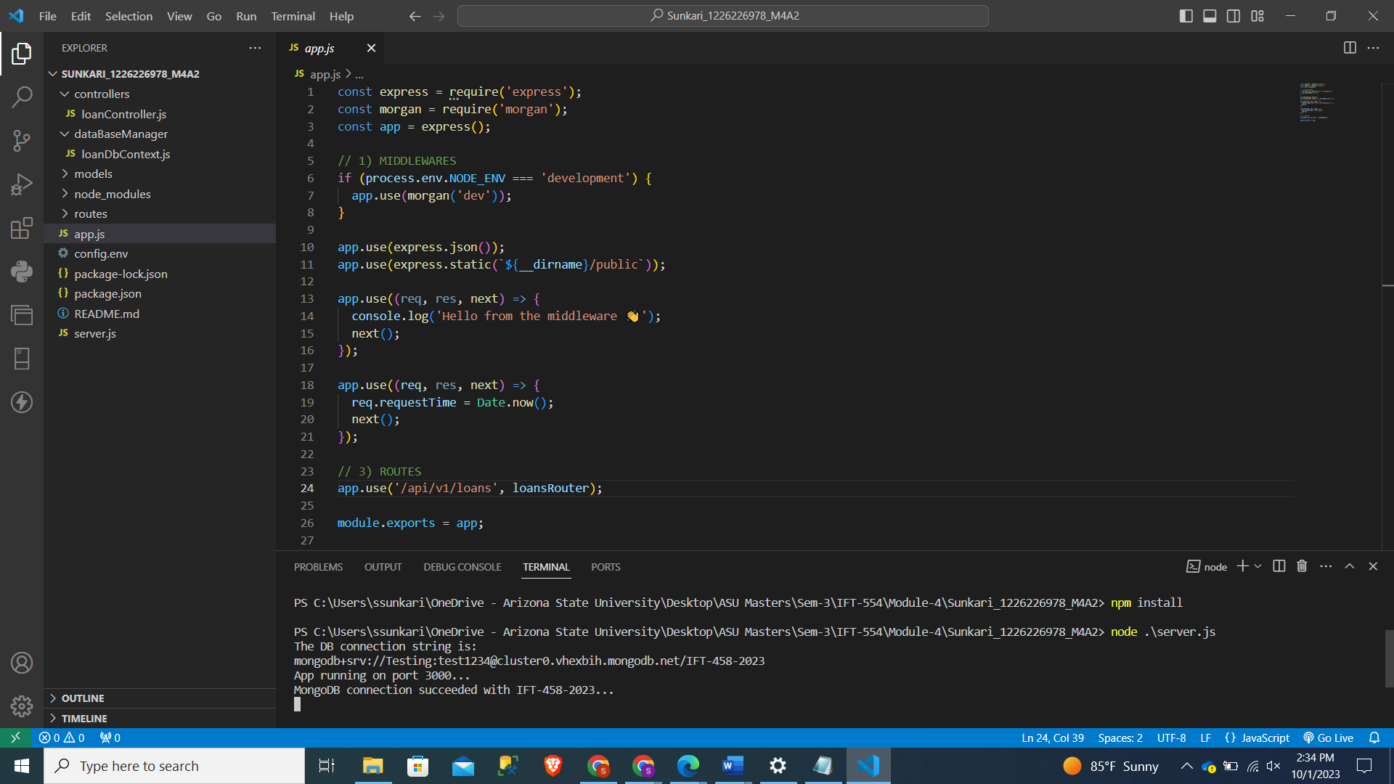

Step 8 – Adding a Loan and Testing in Postman

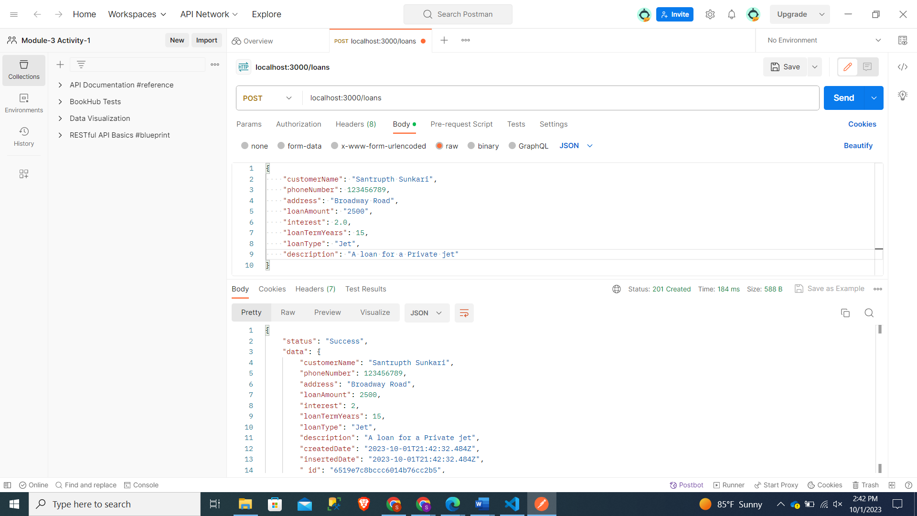

Reflection to MongoDb

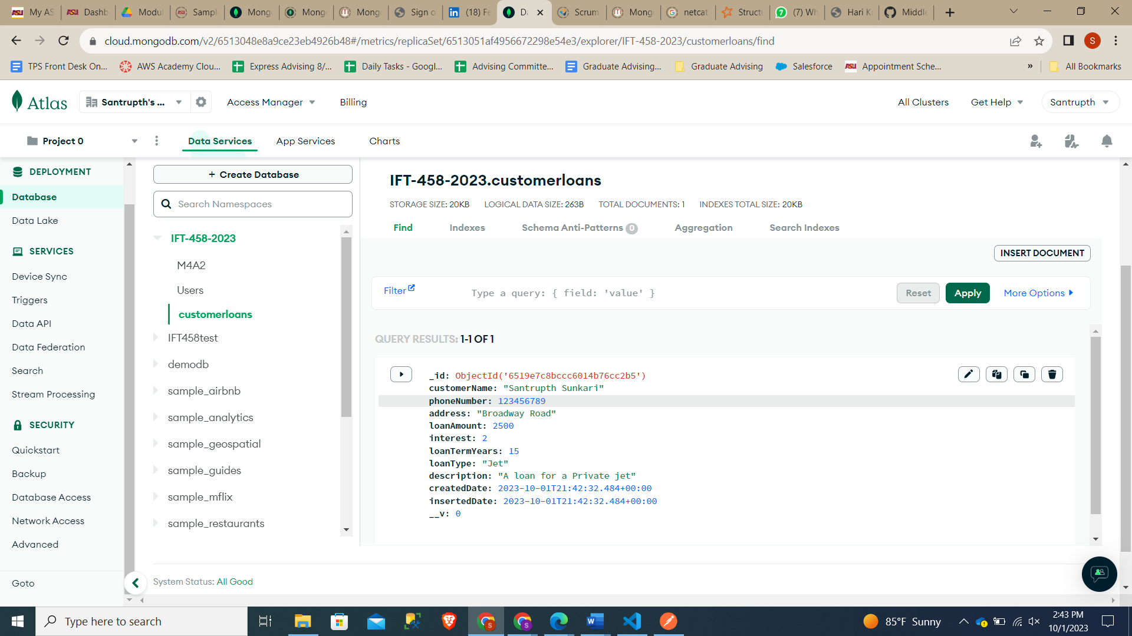

Step 9 – Addition of 5 additional loans in Postman;

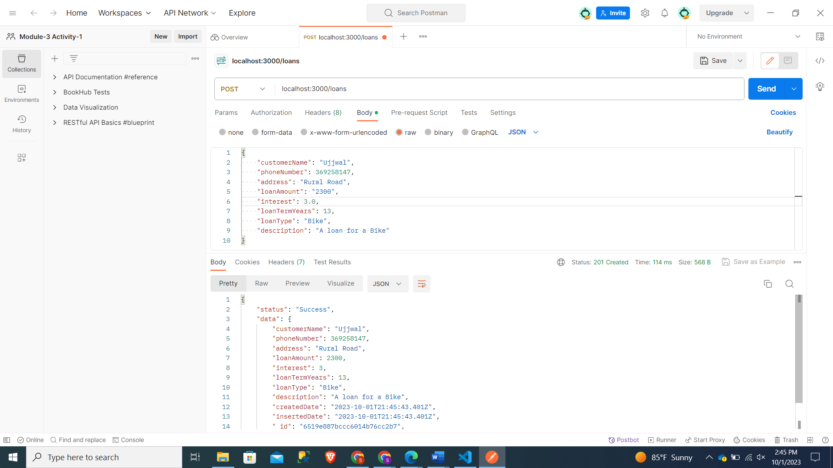

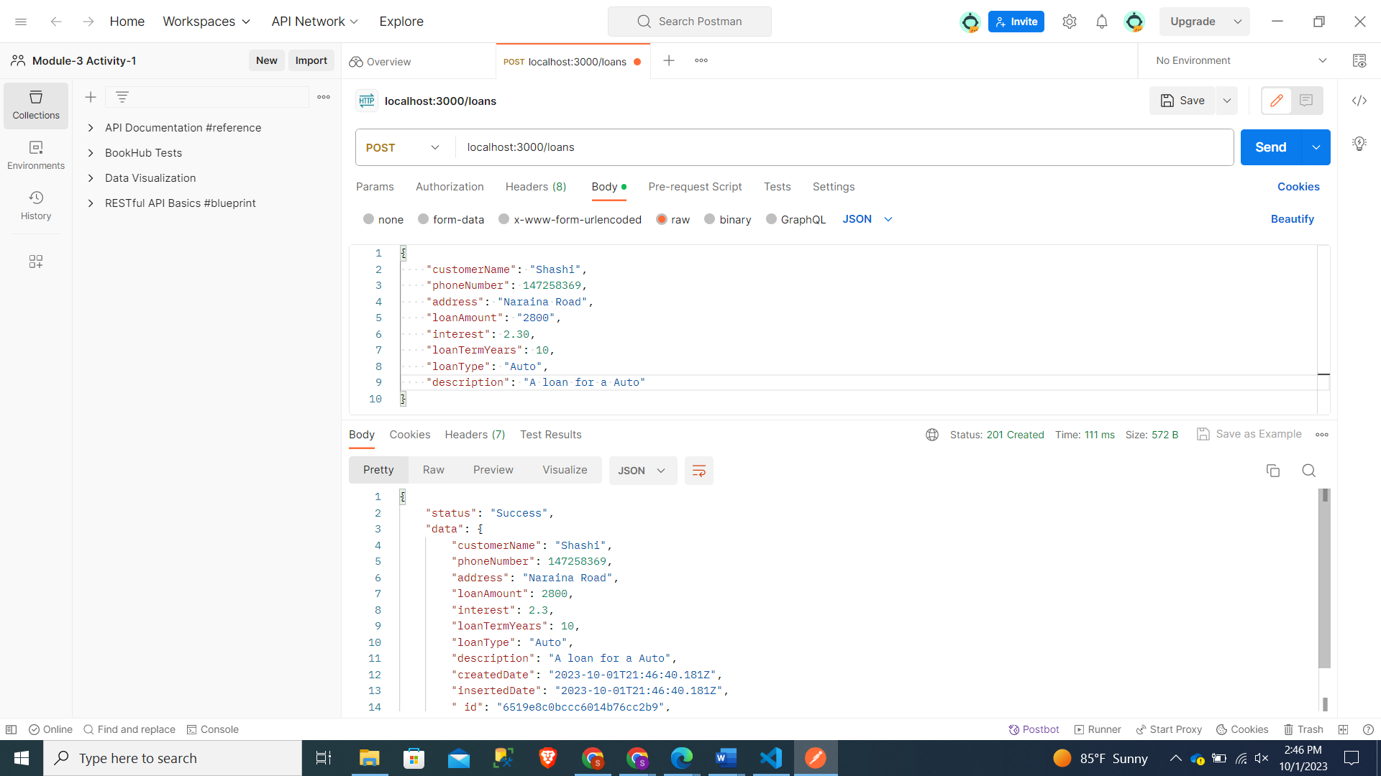

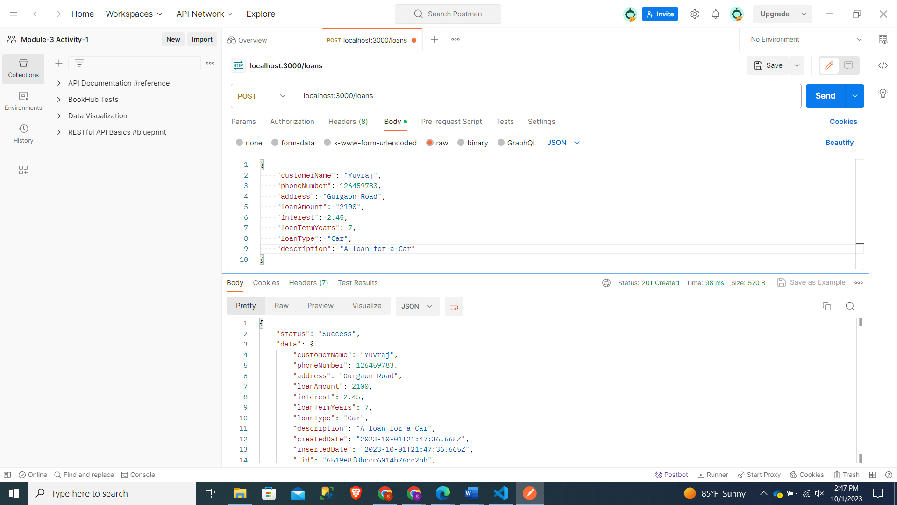

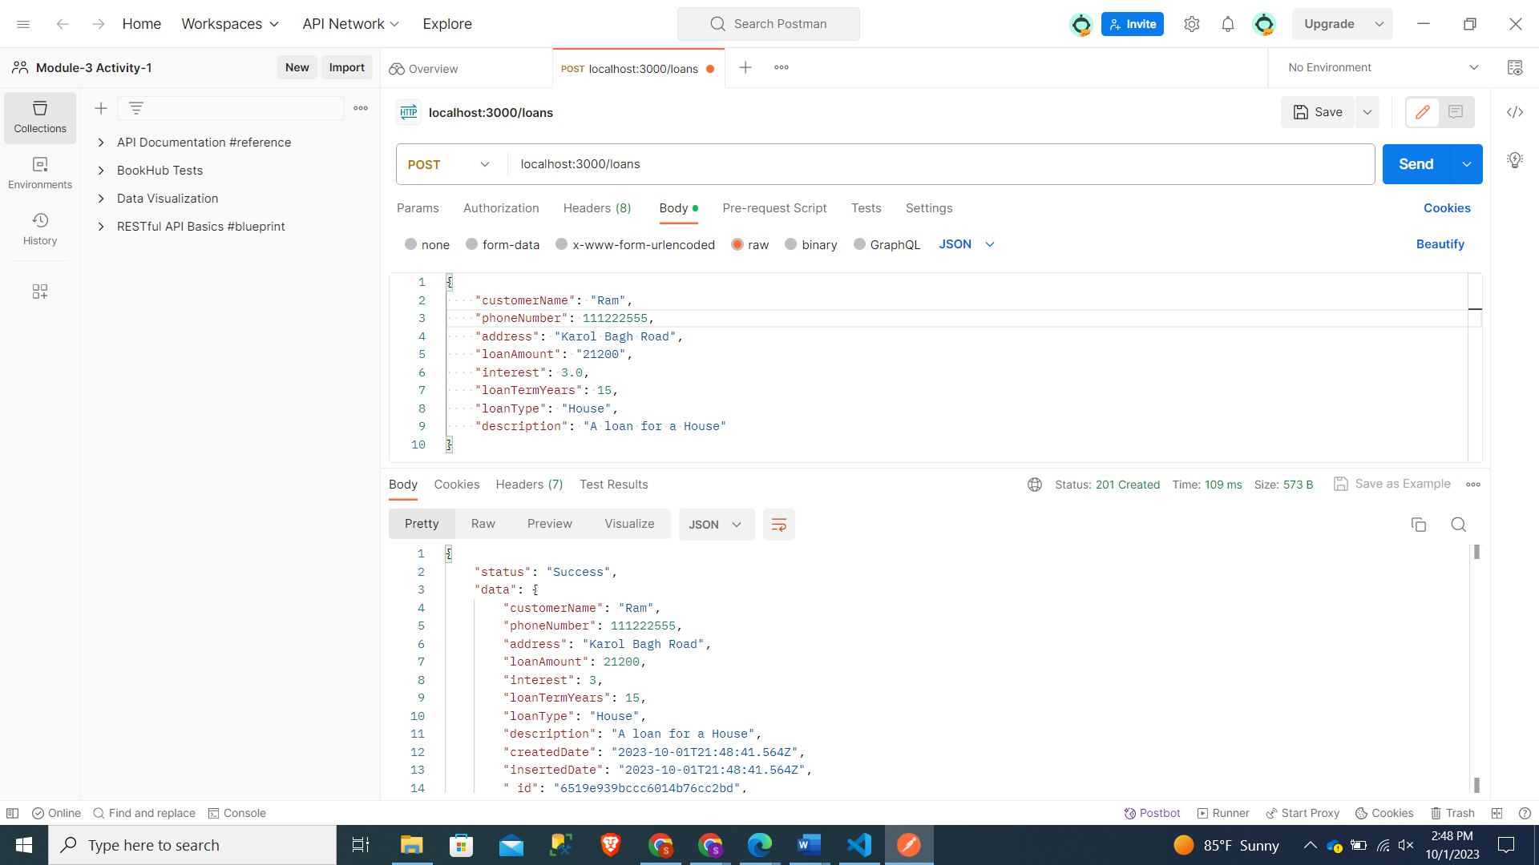

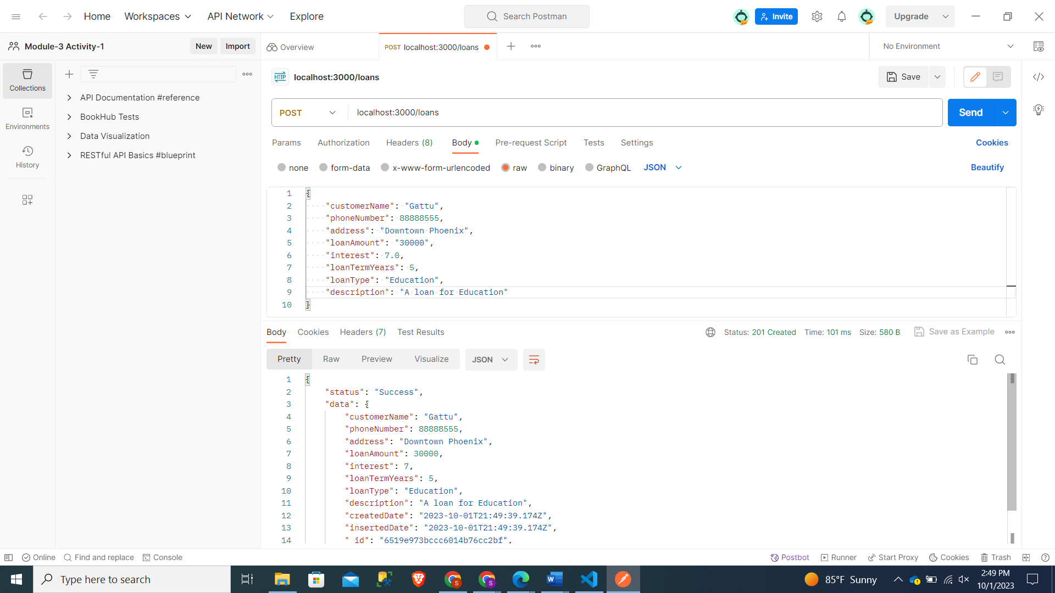

Screenshot of Reflection in Terminal with a error for 1 while adding a data:

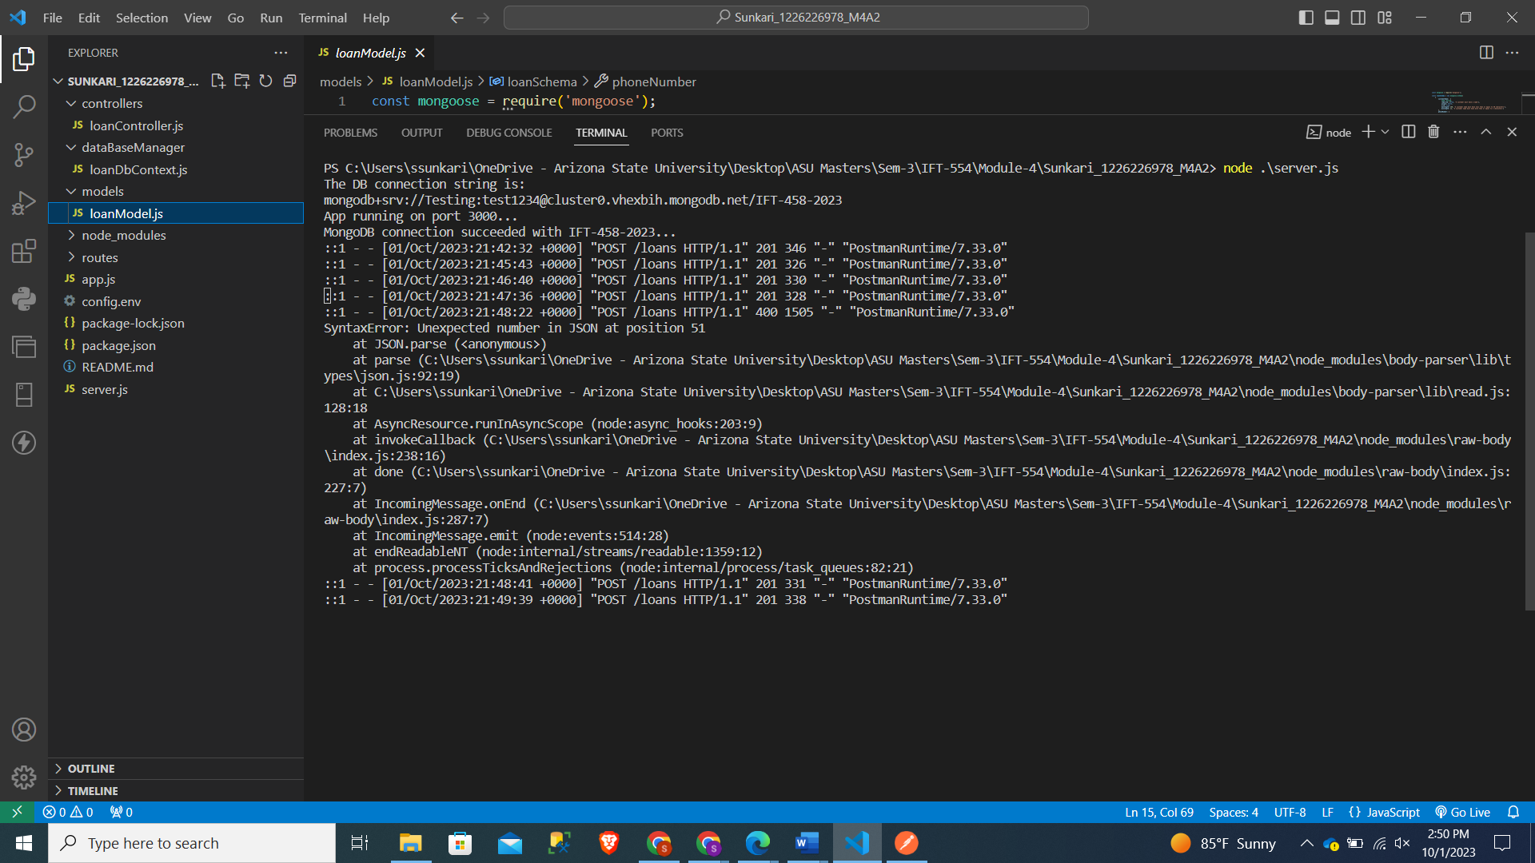

Data Addition for 5 loans in MongoDb

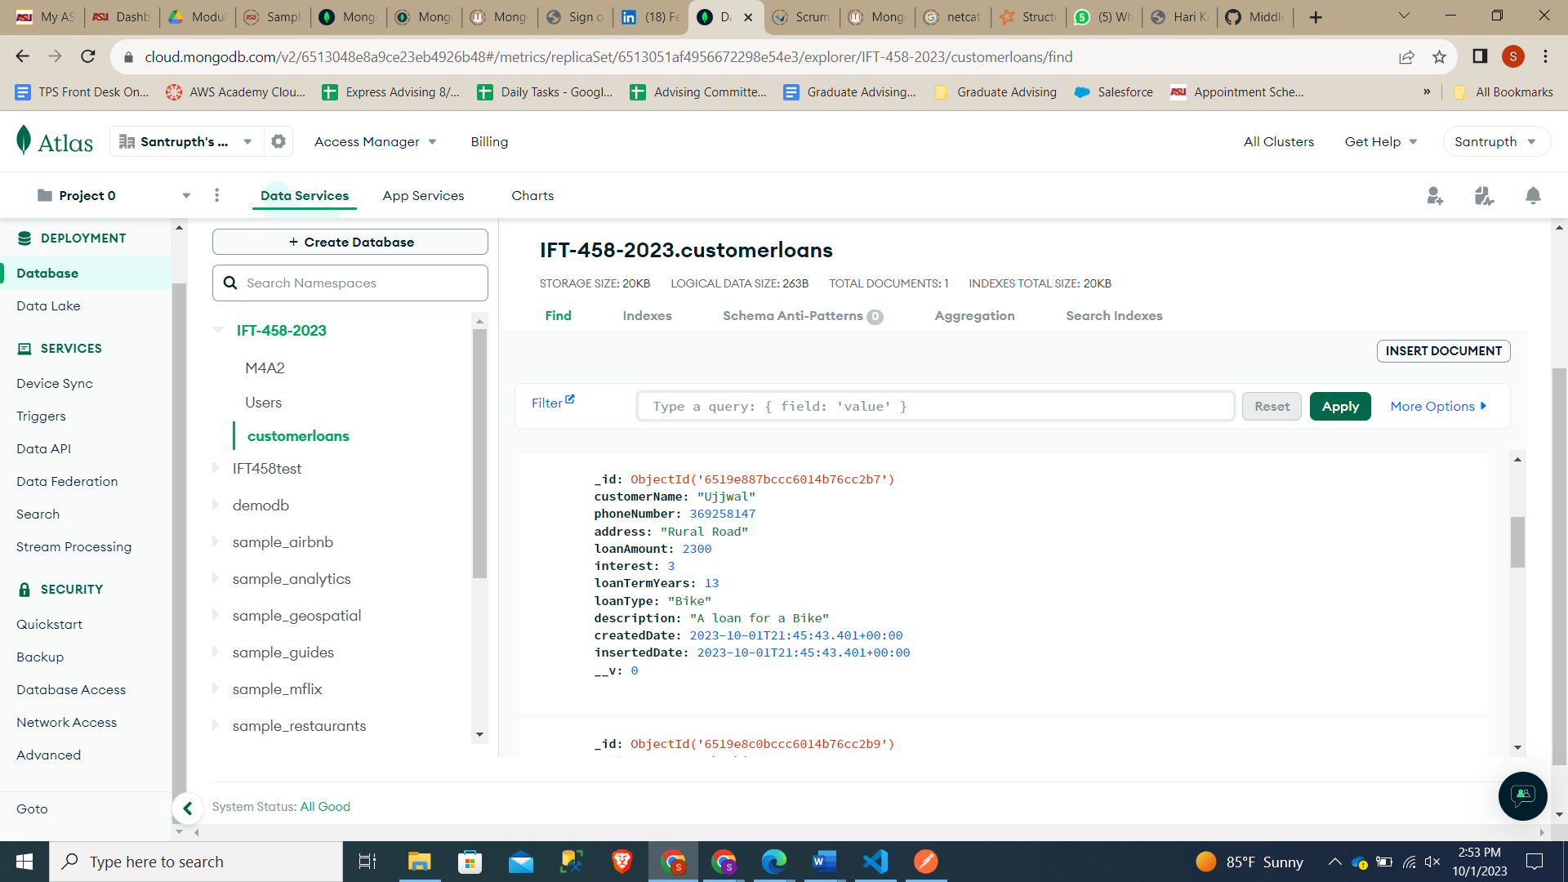

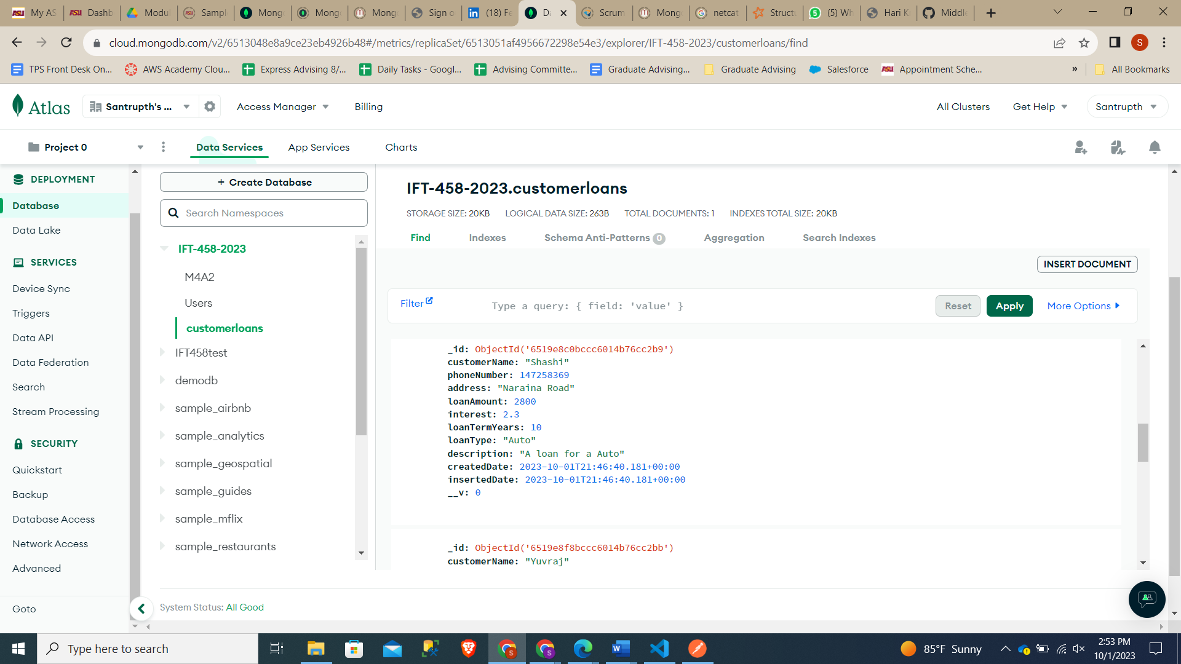

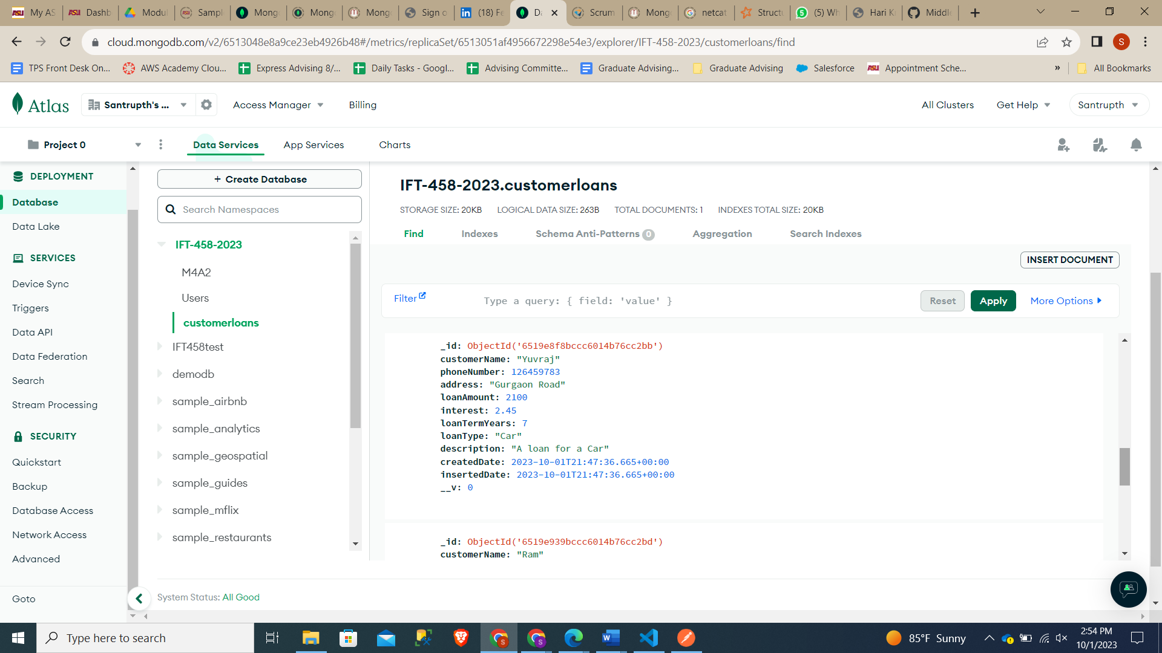

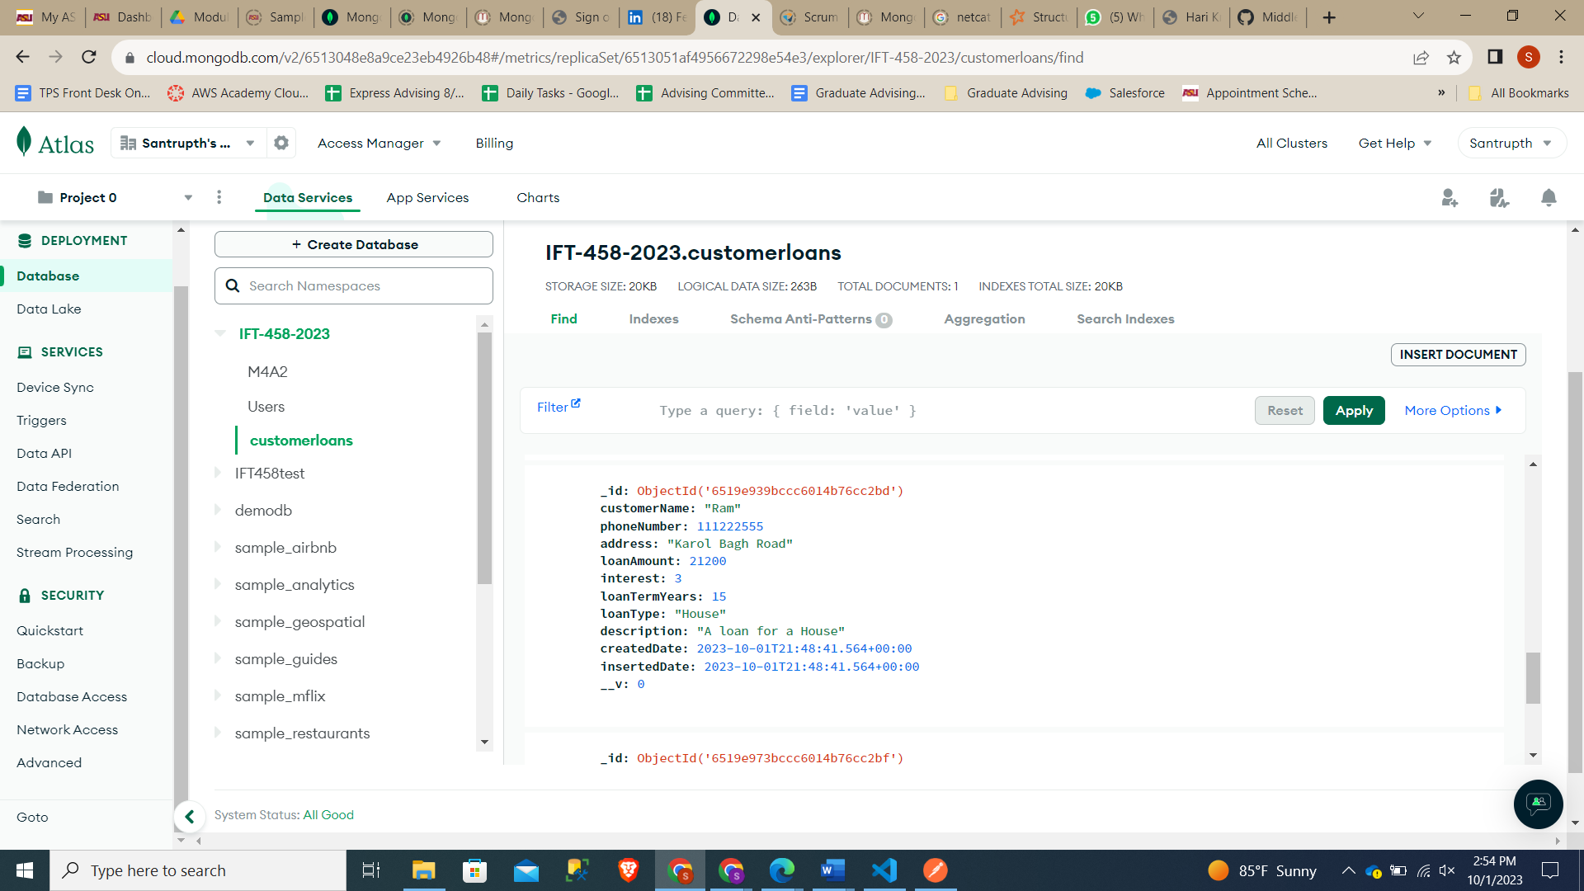

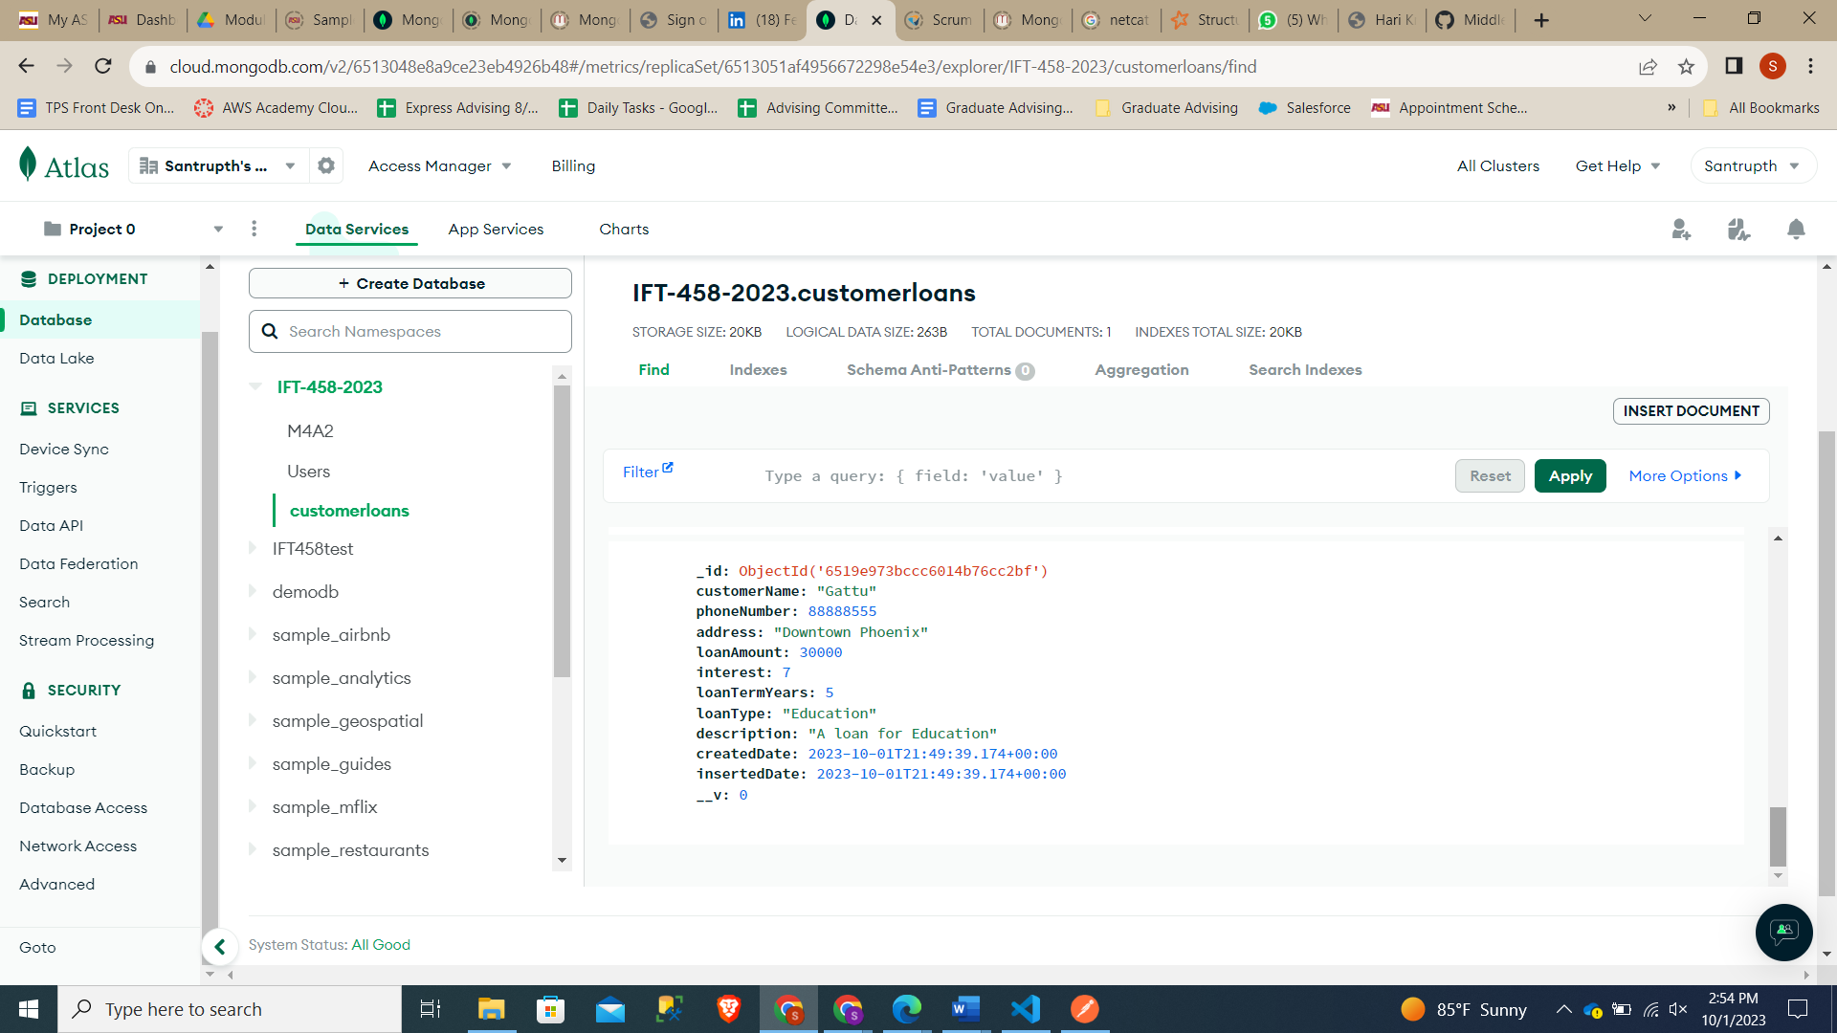

Addition of Other Documents

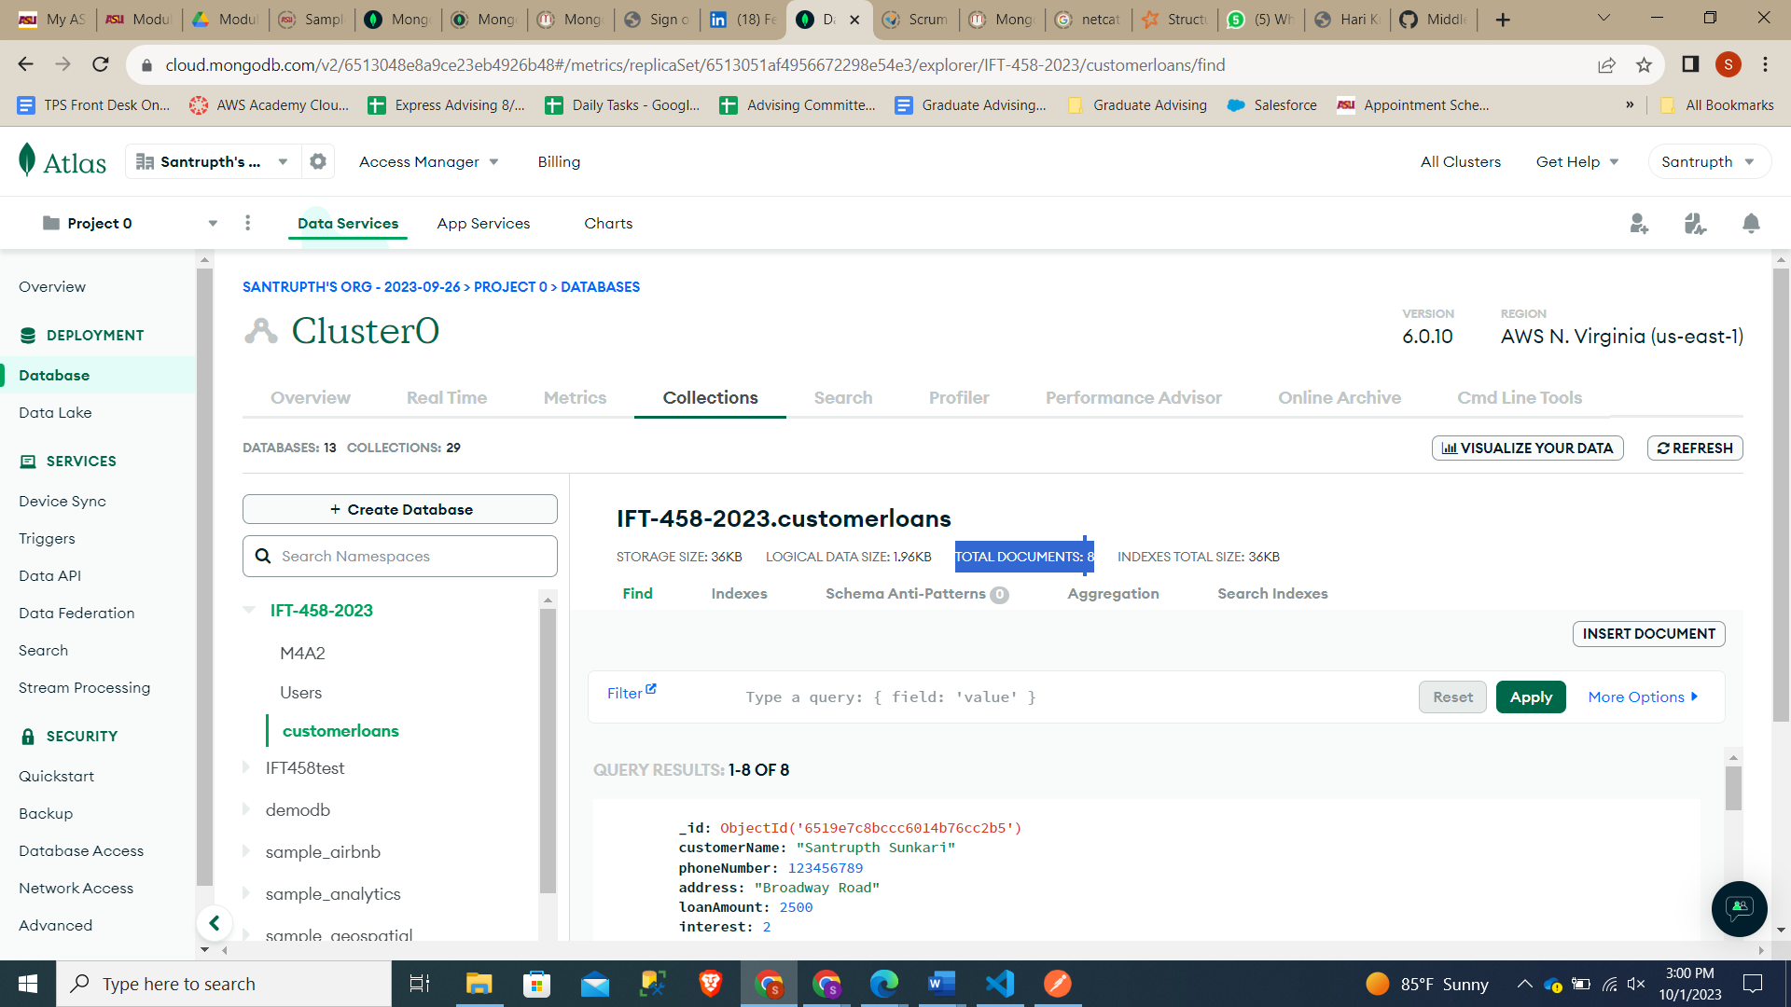

# Step 10 – Get Users To get all users, enter http://localhost:<PORT-NUMBER>/loans/ as the address. Remember to select the verb as GET.

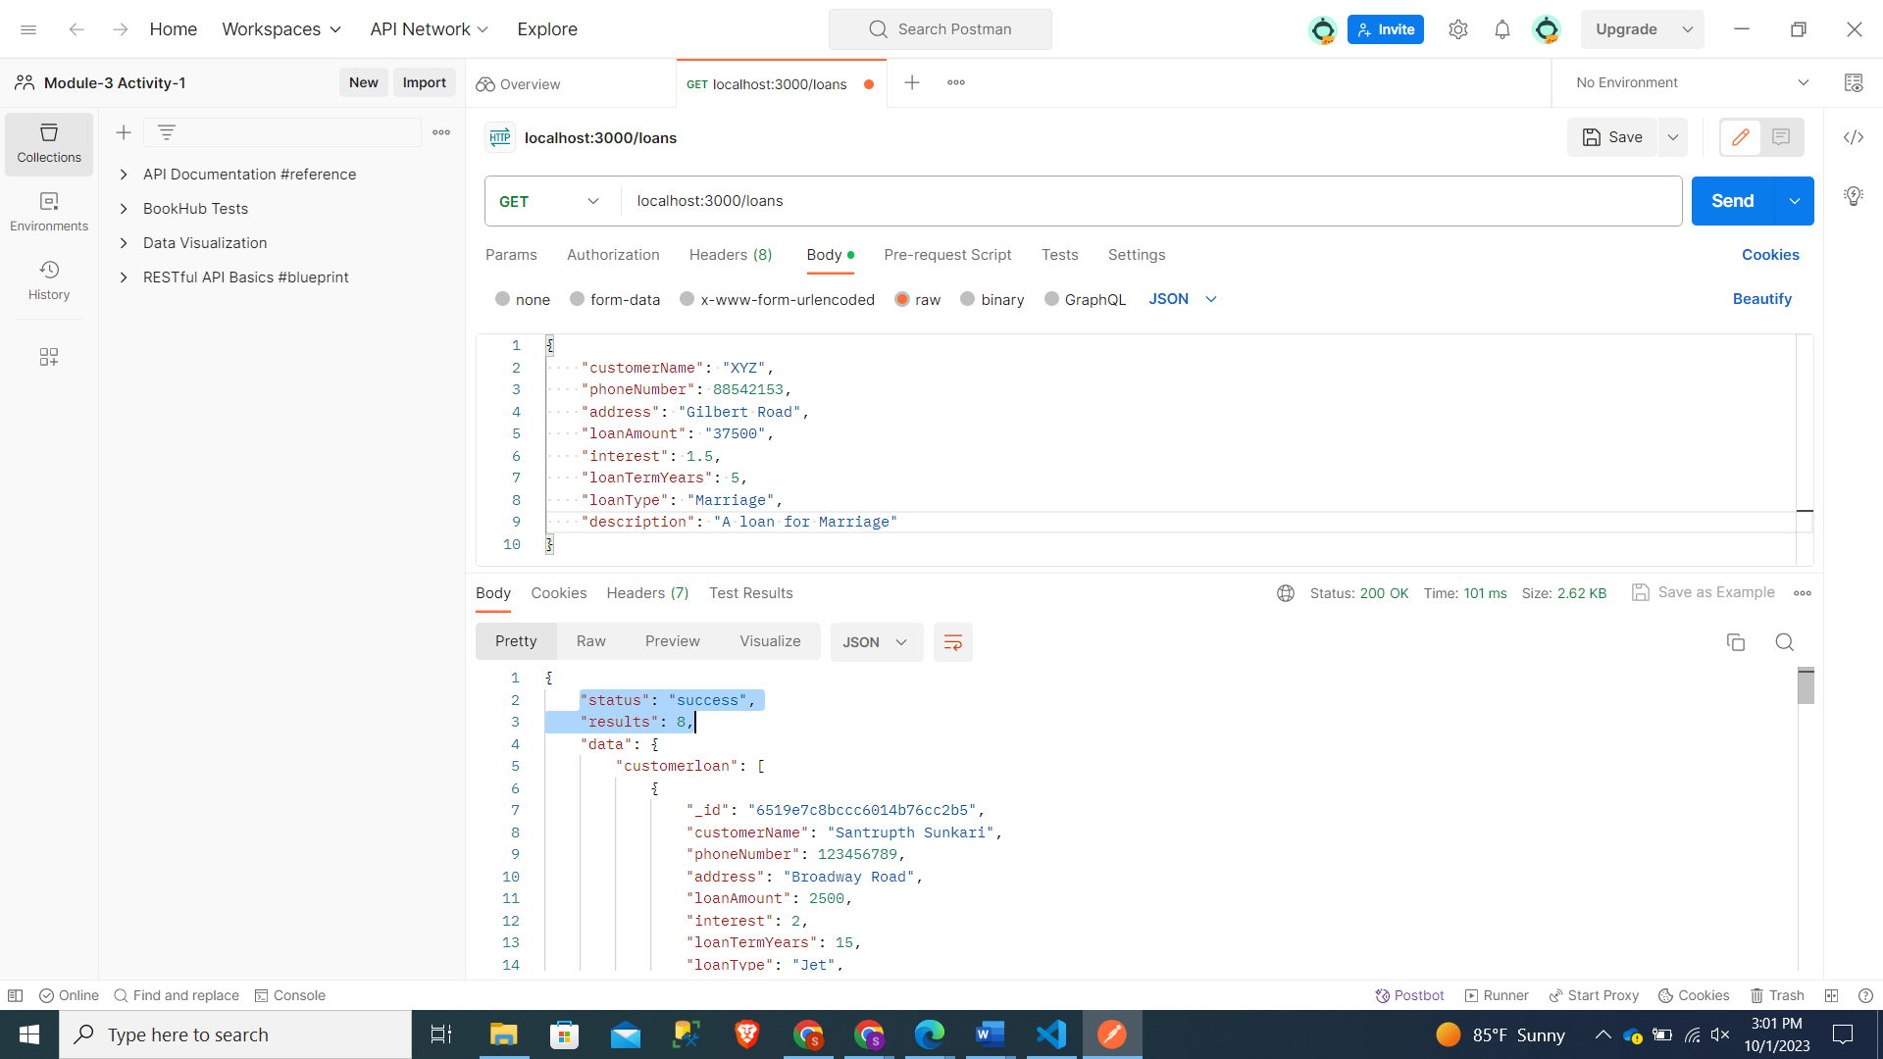

# Step 11 – Get a Specific User (POSTMAN) Get the data of a specific user by entering this URL: [**http://localhost:<PORT_NUMBER>/loans/:id**](http://localhost:%3cPORT_NUMBER%3e/loans/:id)

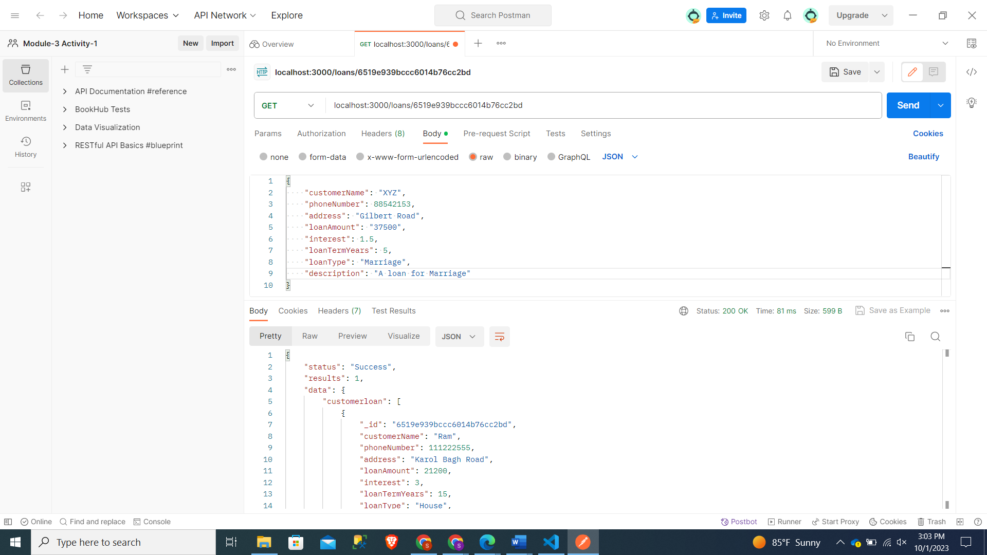

# Step 12 – Change an Existing Loan (POSTMAN) Change an existing LOan by using the PUT verb. Then change the value of the JSON object. The URL is the same as when we fetched the specific Loan.

Prior

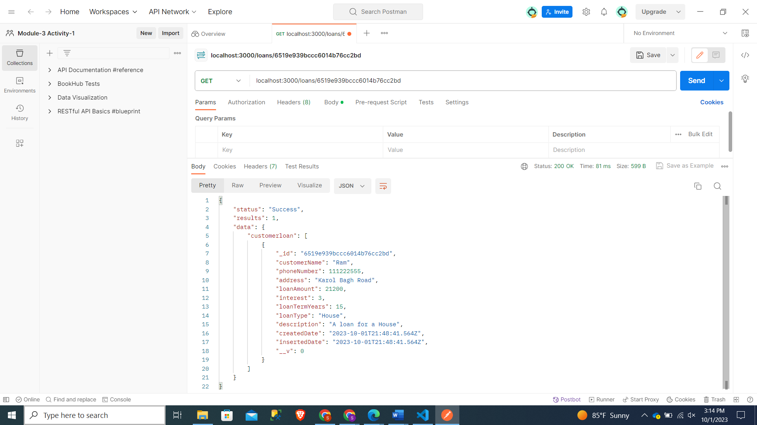

After updation:

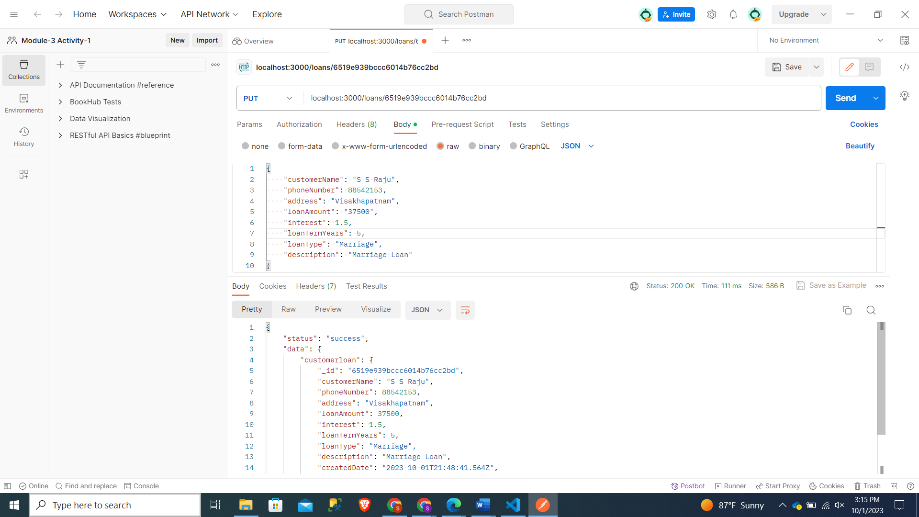

Reflection in MongoDB:

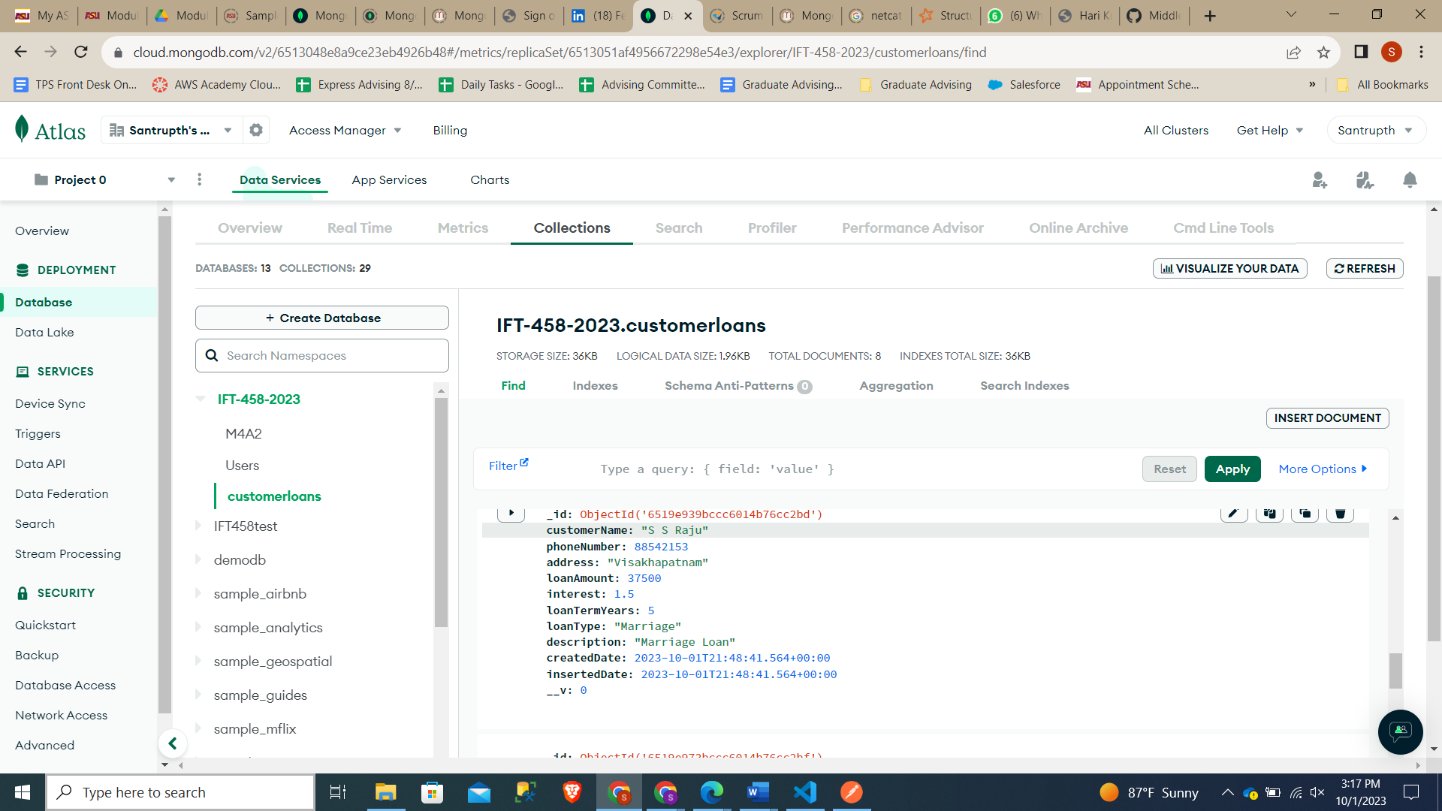

# Step 13 – This criterion is linked to a Learning OutcomeDelete a User (POSTMAN) To delete a loan, you only need to change the verb to DELETE. We can verify that the user is gone by fetching all the loans. Now Verify that you have a fully working express backend connected to a MongoDB database.

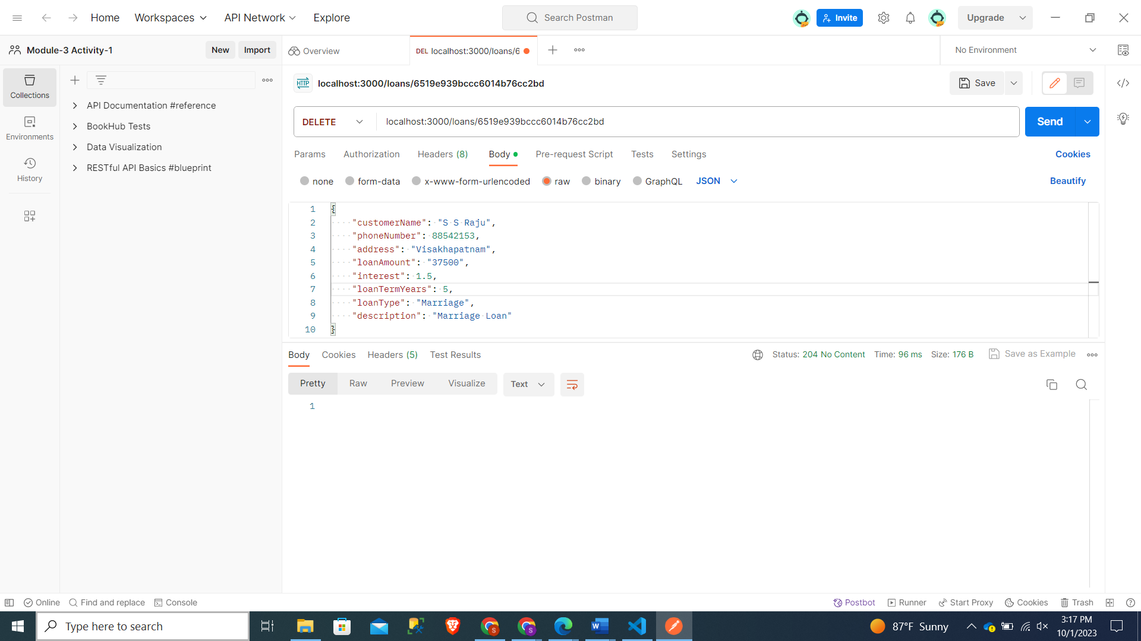

Using Get to verify the Deletion

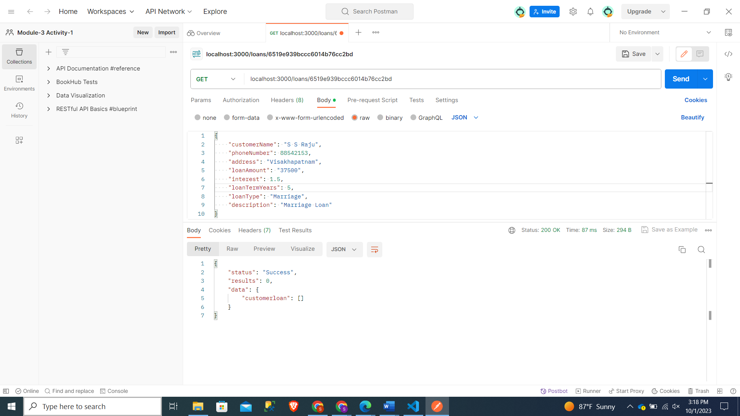

Changes Reflected in MongoDB:

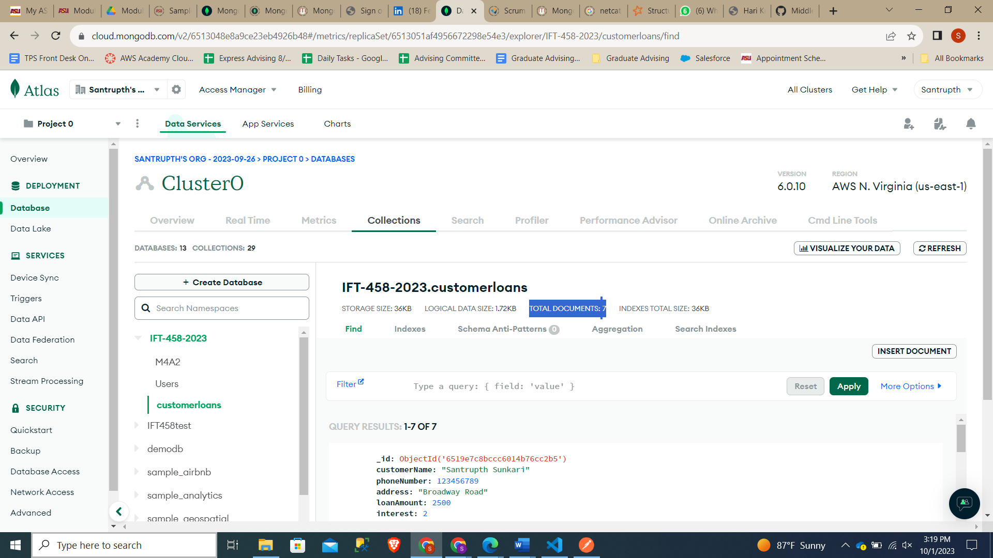

# Step 14 – Create a collection in POSTMAN and all your TEST there and then EXPORT POSTMAN TEST COLLECTION to a json file.

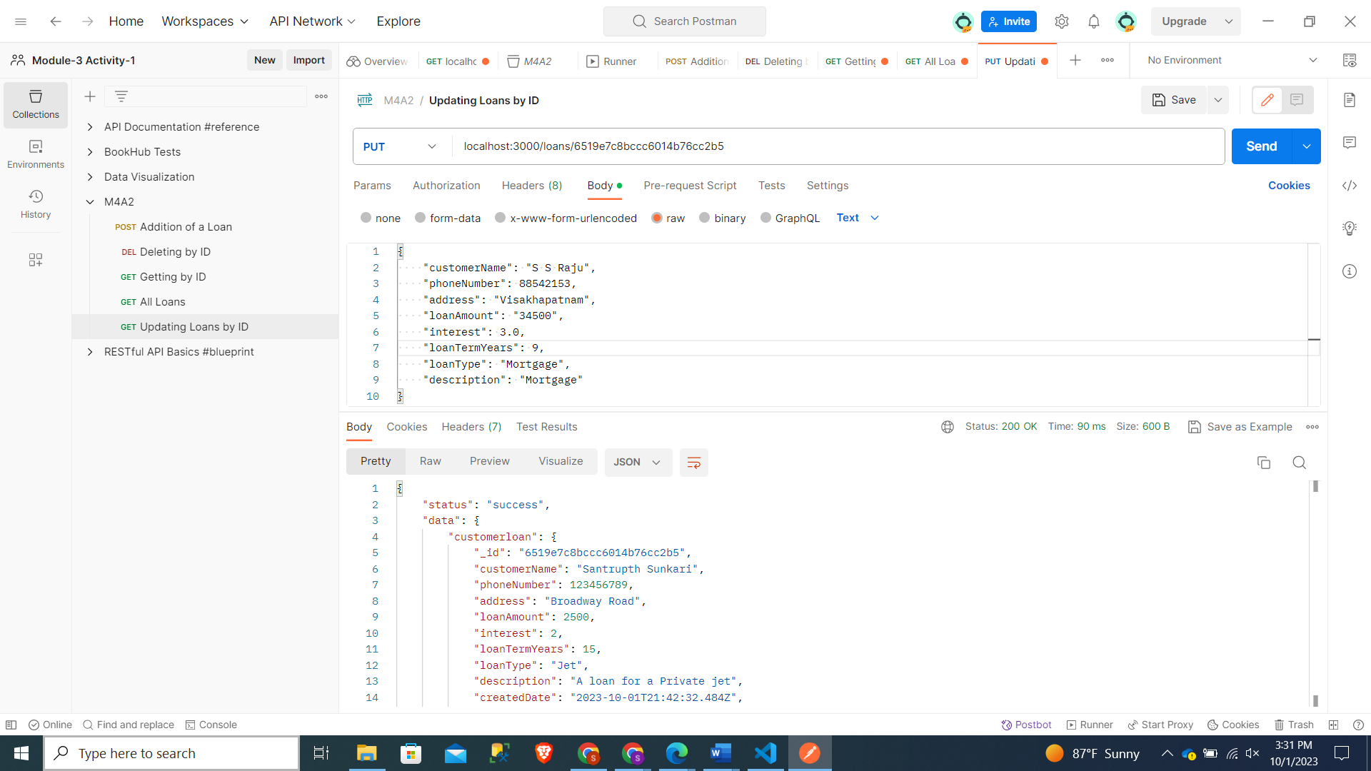

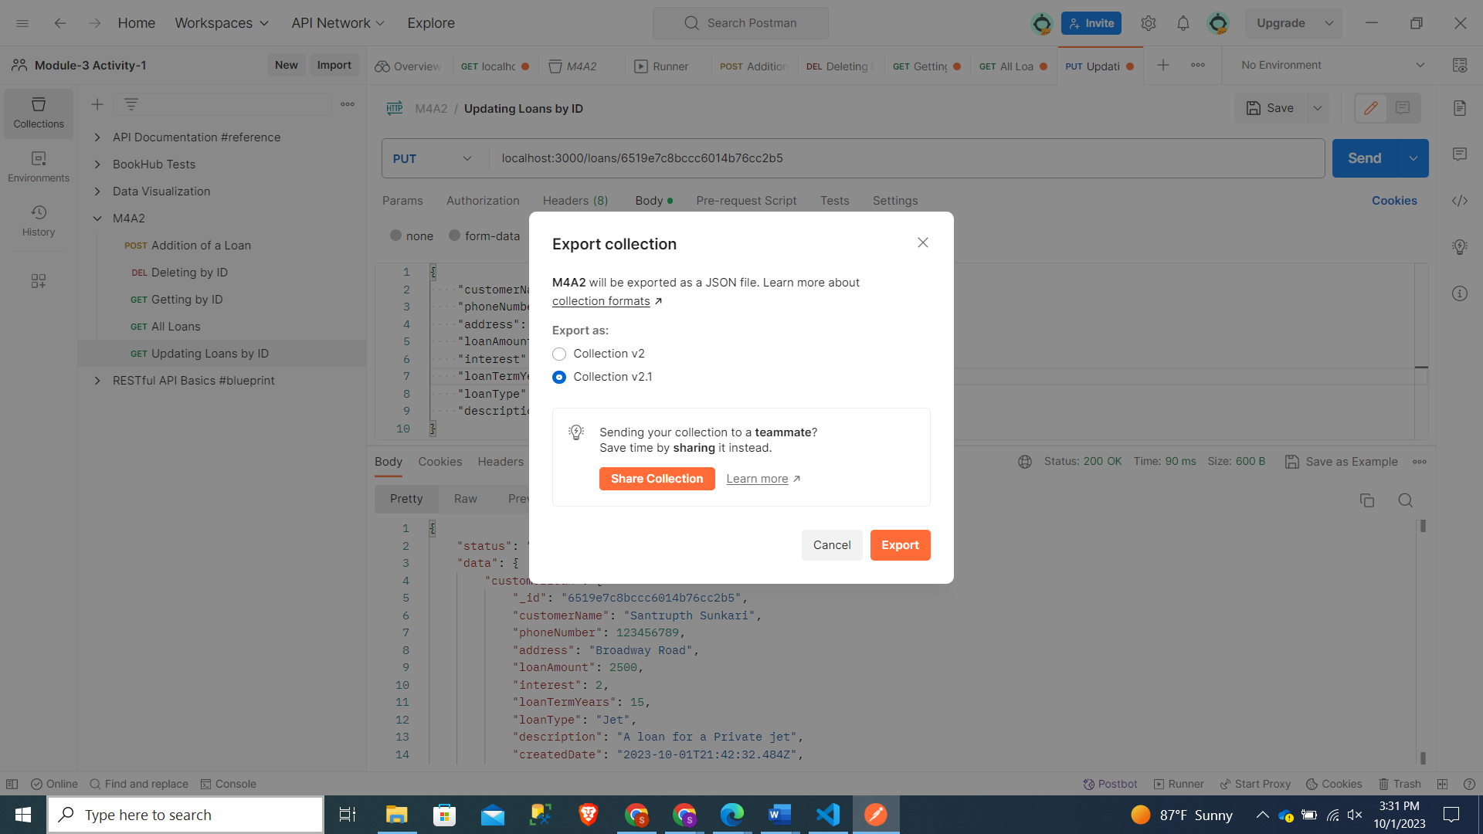

Exported Collection in VS code:

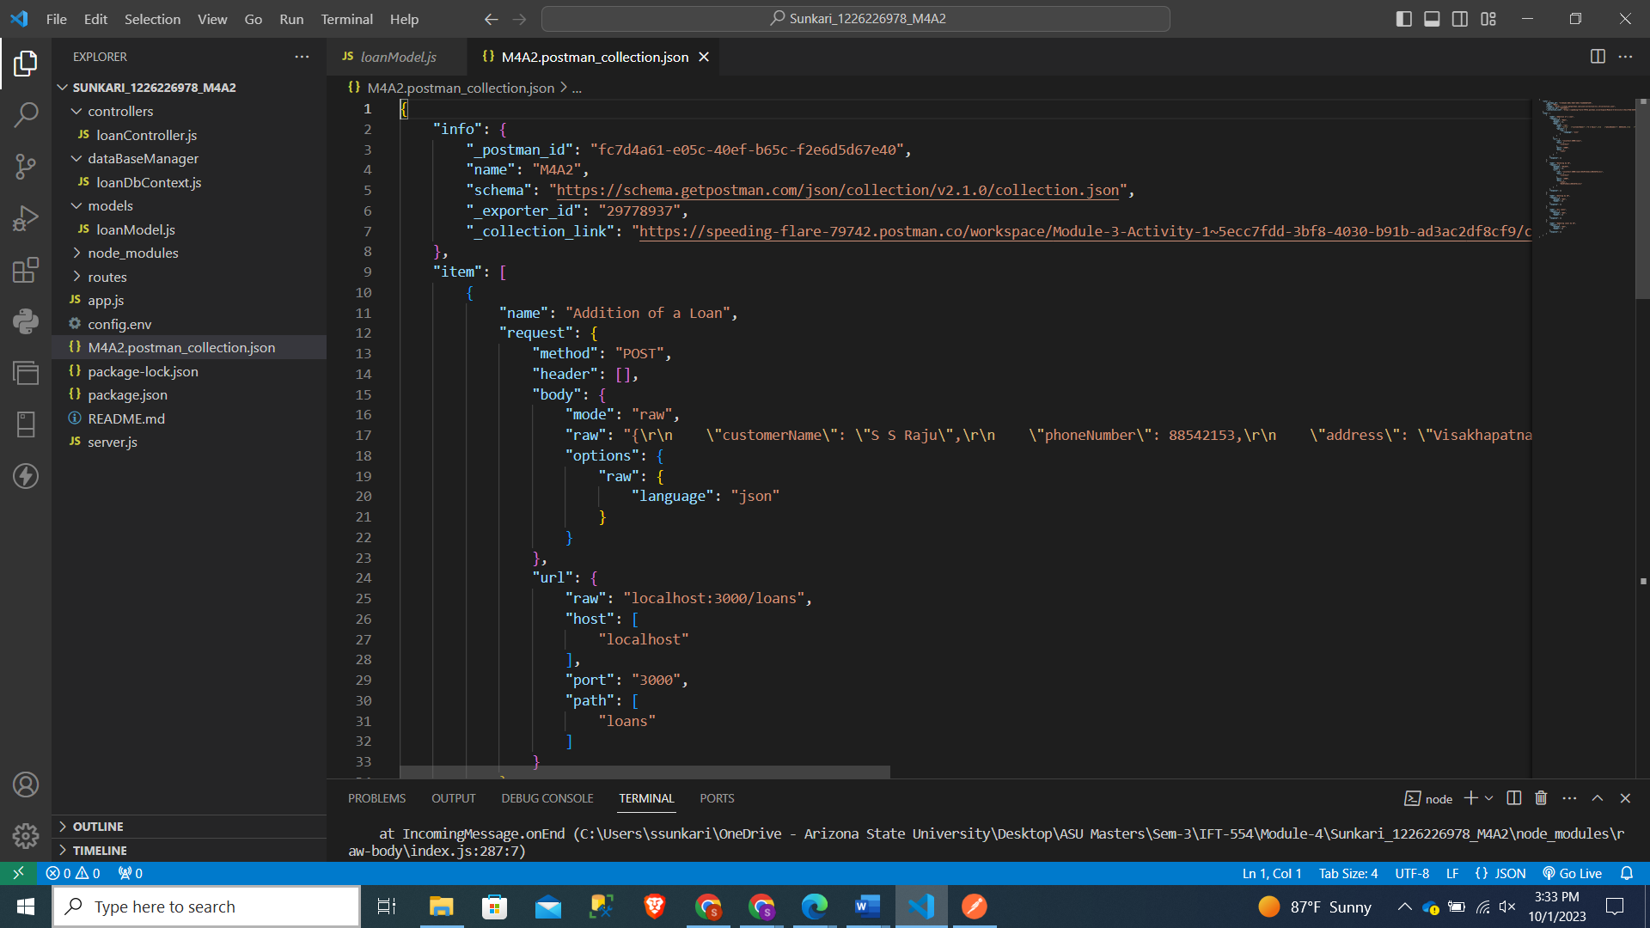

Step 15: Adding Code for displaying connection string which was used in the Console:

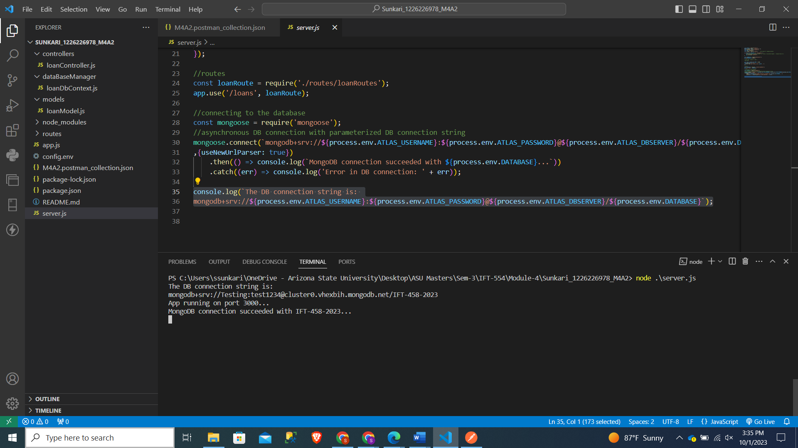

Task 2: (Written Assignment no Code)

1. **Understanding the Codebase**

Looking at individual files to gain more insights and depth knowledge:

**App.js:** This is the start point of the application where express and morgan have been declared.

**Server.js:** This js file is used to start the server, along with providing the connections to the database by providing routes .

**loanModel.js:** This defines the Schema and loans Model.

**loanRoutes.js:** This js file enables the express route for CRUD operations.

**loanController.js:** File consists of the logic for loans.

**Config.env:** A Config file used for declaring the MongooseDB variables.

**loanDbContext.js:** This helps in basic querying like sorting, limiting, filtering database queries.

**Key Components:**

**Express.js:** The application relies on Express.js, a widely-used web framework for Node.js. It serves as the foundation for handling HTTP requests, defining routes, and configuring middleware.

**Mongoose:** Mongoose is employed as an Object-Document Mapping (ODM) library to facilitate interactions with a MongoDB database. It plays a crucial role in defining the schema for loan documents and providing a convenient interface for performing database operations.

**Middleware:** Middleware functions are integral to the request and response processing pipeline. Specifically, the application utilizes Morgan for logging requests during development and Body-parser for parsing incoming JSON requests. Additionally, custom middleware functions are implemented to augment requests with relevant information and execute various tasks.

**Routes:** The loanRoutes.js file is responsible for defining routes that handle Create, Read, Update, and Delete (CRUD) operations for loans. Each route is associated with corresponding controller functions found in loanController.js.

**Controller:** Within loanController.js, you'll find functions dedicated to managing the business logic related to loans. These functions encompass actions like retrieving, creating, updating, and deleting loan records. They communicate with the database through Mongoose models.

**Database Connection**: The application establishes a connection to a MongoDB database by employing the mongoose.connect method. It retrieves the necessary database connection string and credentials from environment variables, ensuring secure database access.

**APIFeatures Class:** In the loanDbContext.js file, an APIFeatures class is defined to enable advanced querying and filtering of database queries. This class is invaluable for tasks like filtering, sorting, field selection, and pagination of query results.

1. **Database and Schema**

In this application we have used MongoDB as the backend, which in this case is Mongoose used to interact with database.

1. Database Connection:

The app connects to MongoDB using Mongoose, for which declared in server.js using the command mongoose.connect method. The database name, userID and Password are fetched from Config.env file.

1. Mongoose Schemas:

In these the structure of documents have been discussed and explained further.

1. **customerName:** This attribute captures the name of the loan applicant. It enforces validation rules, including required input, maximum and minimum length constraints, and trimming. It directly corresponds to a field within the MongoDB document.

2. **phoneNumber:** This attribute stores the phone number of the customer. It adheres to validation rules that mandate required input, maximum and minimum length restrictions, and trimming. Like other attributes, it corresponds to a MongoDB document field.

3. **address:** This attribute represents the physical address of the customer. It follows validation rules for required input, maximum and minimum length limitations, and trimming. It, too, directly maps to a MongoDB document field.

4. **loanAmount:** This attribute signifies the requested loan amount. It enforces validation rules that specify required input, maximum and minimum allowable values, and trimming. It aligns with a field in the MongoDB document.

5. **interest:** The interest attribute denotes the interest rate for the loan. It comes with a default value and validation rules for maximum and minimum acceptable values. It corresponds to a specific field in the MongoDB document.

6. **loanTermYears:** This attribute represents the duration of the loan in years. It is subject to validation rules covering required input, a default value, maximum and minimum permissible values, and trimming. It corresponds directly to a MongoDB document field.

7. **loanType:** This attribute characterizes the type of loan. It enforces validation rules related to required input, maximum and minimum length restrictions, and no trimming. Like others, it maps to a MongoDB document field.

8. **description:** This attribute provides a description of the loan. It follows validation rules dictating required input, maximum and minimum length constraints, and trimming. It corresponds to a specific field within the MongoDB document.

9. **createdDate and insertedDate:** These attributes serve as timestamps, indicating when the loan document was both created and inserted. They come with default values and are associated with respective fields in the MongoDB document.

3. Data Validation and Middleware:

The loan schema enforces validation rules for fields, ensuring data in the database meets criteria like minimum/maximum values and required fields. Middleware functions parse JSON requests and add requestTime to requests.

1. Schema Features: The APIFeatures class in loanDbContext.js enables advanced querying and filtering of database queries, improving query capabilities in the application.

**3. Mongoose ORM**

Mongoose offers a schema-driven approach for efficiently managing and interacting with MongoDB data within Node.js applications. It also offers middleware, validation, and hooks functionalities to enhance data management and modeling.

Schema Definition: The process begins by establishing a schema, which serves as a blueprint detailing the structure of documents, encompassing fields, their data types, and any validation criteria.

Model Creation: After defining the schema, a model is created based on that schema. A model serves as a representation of a database collection and facilitates Create, Read, Update, and Delete (CRUD) operations.

CRUD Operations: Various functions such as save, find, findOne, findById, update, findOneAndUpdate, findByIdAndUpdate, deleteOne, deleteMany, and findByIdAndDelete are available within the model to handle data interactions within the database.

1. **Extending the Code:**

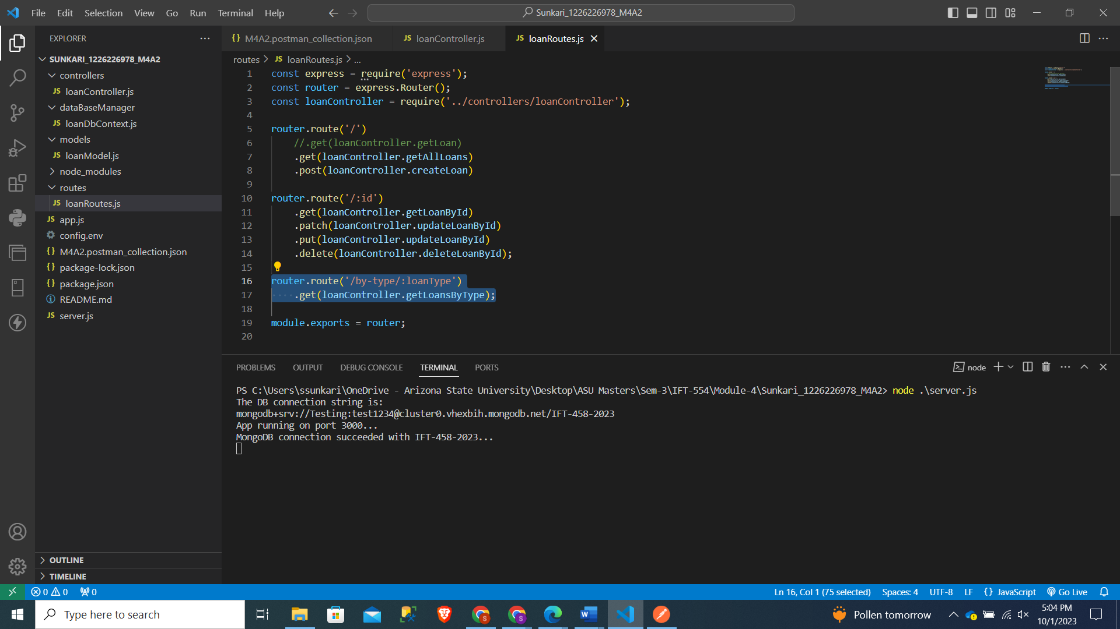

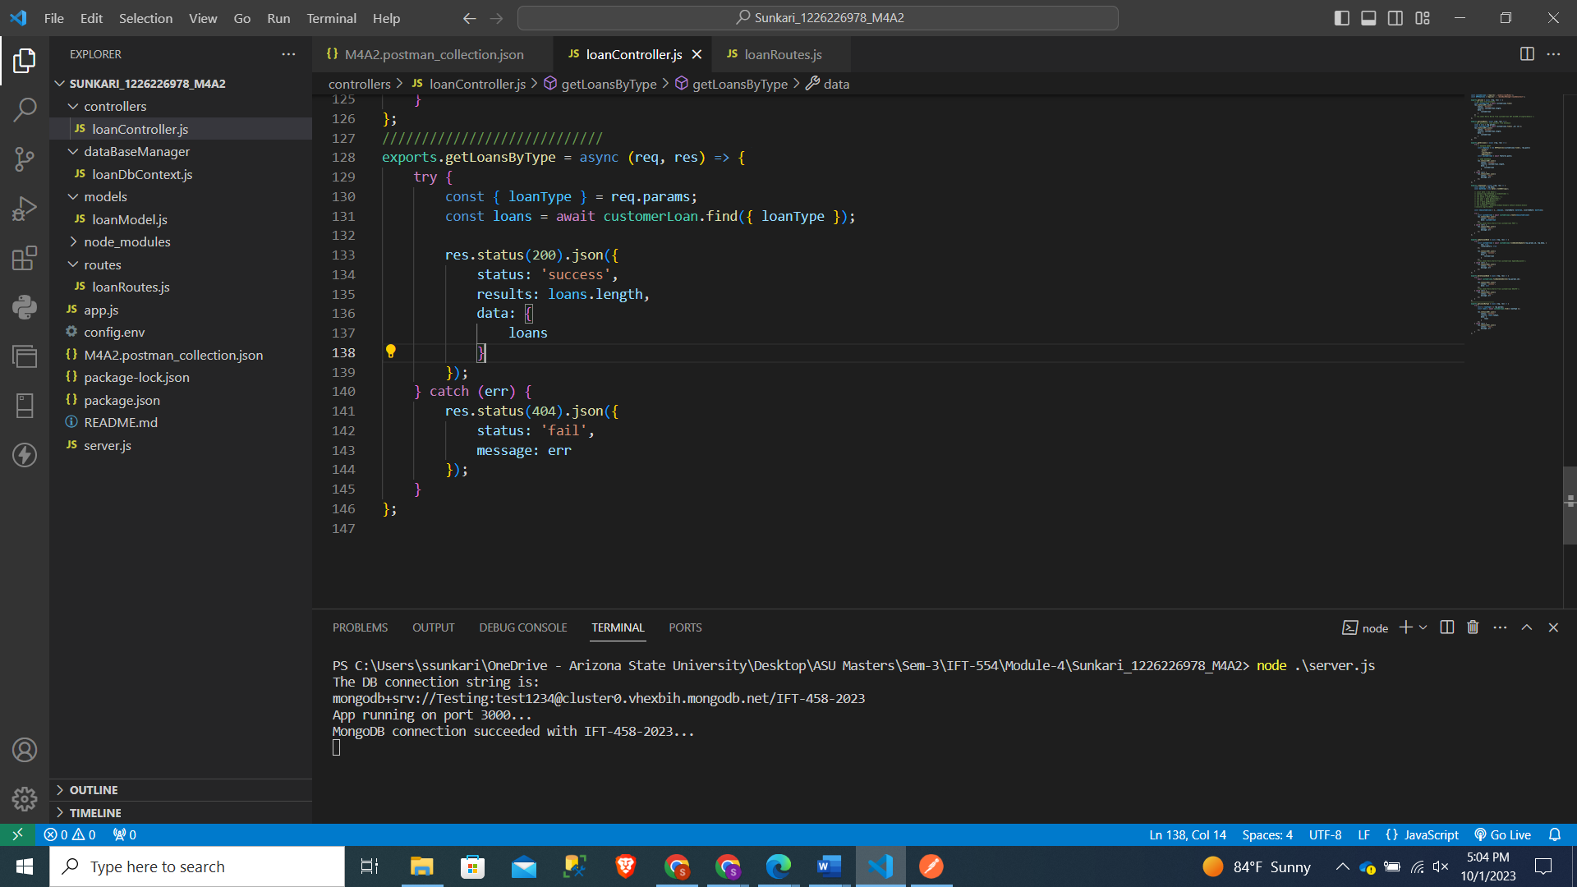

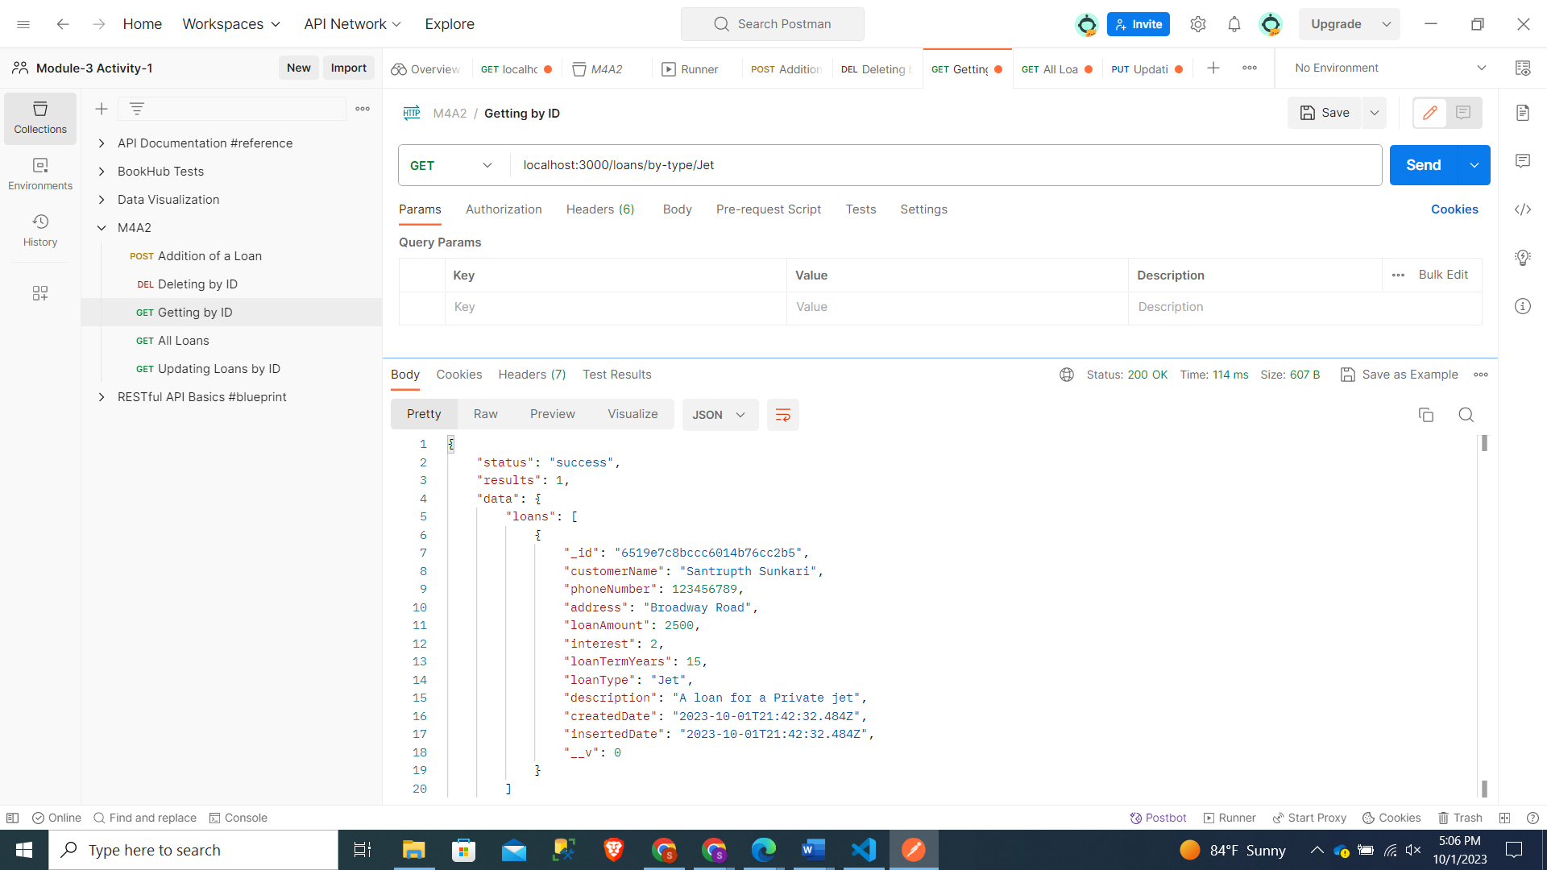

1. **Tests:**

Unit tests can be implemented to verify the accuracy of loan data. Given that the schema enforces limitations on the permissible content of each attribute, unit tests can be employed to assess these schema constraints when validating post data. These validations pertain to several aspects:

1. Length of Attribute Values

2. Attribute Uniqueness and Presence

3. Attribute Data Types

4. Default Attribute Values

In addition to these, tests associated with the API can be integrated as well. These API tests encompass the validation of API responses, status codes, and data received in comparison to predefined data.

The main emphasis of testing is to verify whether the application parts act as defined and function as wanted. This benefits from catching early issues in development and API retrieves the wanted responses.

**Task 3:**

**Understanding Code Structure:**

The codebase is organized using packages to separate models, controllers, middleware, and database connections. Each package functions independently and follows SOLID design principles. Essential features like data storage, server monitoring, and request data parsing are provided by external libraries like mongoose, dotenv, morgan, and body-parser.

Mongoose connects to the Atlas server's MongoDB using a connection string, username, and password. Data validation and schema checks are defined within a schema, and a dedicated database stores loan-related information. Database connection code is isolated in its file for easier maintenance. Accessing the database collection is done through mongoose.model, enabling interaction with the schema-defined structure.

**Learnings:**

* We began by adding the database in the server.js file.
* Database Credetials are taken and kept in other file named config.env which enables privacy.
* Server connections are kept in Server.js.

**Differences and Similarities:**

**Differences:**

Database Integration: This task involves setting up and integrating a MongoDB database, which differs from previous projects that may have used relational databases like MySQL or PostgreSQL.

Testing Framework: The use of Jest and Supertest for unit testing may be new if you've worked with different testing frameworks in the past.

**Similarities:**

Middleware: Utilizing middleware functions to manage requests and responses is a common practice in Express.js applications.

Data Models: Defining data models (in this case, the loan model) and executing CRUD operations on them is a standard part of web development projects.

**Challenges and Solutions:**

Creating comprehensive unit tests, particularly for routes and controllers, can be challenging. It demands a deep understanding of the components being tested and the ability to cover various scenarios.

**Codebase Extension:**

The code structure facilitates modifications and additions. Integrating the REST API was straightforward due to the system's user-friendly design, and a loan type filter was seamlessly added.

**Testing:**

Tests in the application are primarily divided into two categories: model validation tests and route handling tests. These categories serve distinct purposes in ensuring application reliability.

Overall, by testing we can verify the tests and route handling cases which help to test application by providing that created data model is correct and API gives the expected response.

**Reflecting on the learning experience:**

The concept of creating applications with future maintainability in mind provided a fresh perspective. Acquiring knowledge about code structuring, mongoose, and server configurations contributed to this viewpoint. Leveraging previous experience with mongoose, the MongoDB model, and mongoose ORM, along with the capability to isolate recursive DB actions into dedicated files for better context, proved to be valuable skills applied during this assignment.

**GITHUB Repo Link**